
e
Moroccan Tunnels
Advanced Data Analysis| Machine Learning | Cybersecurity
31 décembeR 2025
SUPERVISED BY : DR. Professor EL MKHALET MOUNA
Presented by: Lahlou Chaimaa


Acknowledgments:

I would like to express my deepest gratitude to my academic institution and my instructor El Mkhalet Mouna for providing me with the skills and knowledge necessary to carry out this data analysis project. This work represents the culmination of my learning in multivariate statistics and data science applied to infrastructure.
This academic project was undertaken as part of my educational journey, and I express my gratitude for the academic freedom that allowed me to explore advanced statistical methods on a concrete topic of national interest. The analysis of Moroccan infrastructure, although based on generic data for this project, enabled me to apply theoretical concepts to a real-world problem.
Finally, I thank all the professionals in the field of infrastructure whose research work and scientific publications have informed my methodological thinking and analytical approach.

Project Overview:

This academic project analyzes 100 Moroccan tunnels using 8 technical variables. It applies a sequential, integrated methodology—from exploratory statistics to machine learning—to demonstrate advanced multivariate analysis.
Methods Used:
The study employs a stepwise approach: descriptive statistics, Principal Component Analysis (PCA) for dimensionality reduction, K-Means clustering, Random Forest regression for prediction, anomaly detection (Isolation Forest, Local Outlier Factor), and Correspondence Analysis (CA).
Main Results:
Data shows high variability among tunnels. PCA identified key interpretable components. Clustering revealed distinct tunnel groups. Random Forest models effectively predicted operational duration. Anomaly detection pinpointed atypical tunnels. CA uncovered meaningful associations between variable categories.
Contribution:
The project showcases rigorous, integrated statistical application to infrastructure data, providing a reproducible framework for assessment, segmentation, and predictive maintenance. Visualizations support clear communication of results.
Keywords:
Multivariate analysis, PCA, K-Means clustering, Random Forest, Anomaly detection, Correspondence Analysis, Infrastructure management, Predictive maintenance, Data science, Statistical modeling.

Table des matières
1.1 Context of Moroccan Underground Infrastructure 7
1.1.1 Development of the Moroccan Road Network 7
1.1.2 Strategic Importance of Moroccan Tunnels 7
1.1.3 Technical Challenges Specific to Morocco 7
1.2 Dataset Presentation and Analytical Problem 8
1.2.1 Description of the 100 Analyzed Tunnels 8
1.3 Theoretical Foundations of Principal Component Analysis 9
1.3.1 General Principles of PCA 9
1.3.2 Methodological Steps of PCA 9
1.4 Application of PCA to Moroccan Tunnels 12
1.4.1 Data Preparation and Standardization 12
1.4.2 Calculation of Eigenvalues and Inertia Analysis 13
1.4.3 Visualization of Results 15
1.5 Summary and Implications for Tunnel Management 19
1.5.3 Limitations and Future Perspectives 19
1.5.4 Conclusion 20
1. Theoretical Foundations of K-Means Clustering 21
1.1 Principles of the K-Means Algorithm 21
1.1Data Preparation for Clustering 21
2. Application of K-Means with Different K Values 22
2.1 Configuration with K = 3 Clusters 22
2.2 Configuration with K = 4 Clusters 23
2.3 Comparative Analysis and Selection of the Optimal Number 24
3. Theoretical Foundations of the Random Forest Algorithm 25
3.1 Principles of Random Forests 25
3.2 Performance Metrics for Regression Models 25
3.3 Variable Importance 26
4. Application of Random Forest to Service Life Prediction 26
4.1 Preparation of Compared Datasets 26
4.2 Results on Original Data 26
4.3 Results on Standardized Data 27
4.4 Results on Principal Components 28
4.5 Synthetic Comparison and Recommendations 29
1. Theoretical Foundations of Correspondence Analysis 31
1.1 General Principles of CA 31
1.2 Mathematical Methodology 31
1.3Association Measures and et Statistical Tests 32
2. Préparation des données pour l'AFC : discrétisation des variables quantitatives 33
2.1 Nécessité de la discrétisation 33
2.2 Méthodes de discrétisation appliquées 33
2.3 Discretization Results for 8 Variables 34
3. Application of CA to Discretized Tunnel Data 35
3.1 Calculation of Masses and Deviations from Independence 35
3.2 Singular Value Decomposition and Eigenvalue Analysis 35
3.3 Factor Coordinates and Quality of Representation 36
4. Interpretation of the F1-F2 Factor Plane 36
4.1 General Structure of the Factor Plane 36
4.2 Associated Modality Groups 37
4.3 Specific Associations Revealed by CA 38
4.4 Technical Interpretation of the Results 38
5.1 Comparison with PCA and Clustering Results 38
5.2 Limitations and Interpretative Cautions 39
5.6 Synthetic Conclusion 39
1. Cybersecurity Context for Critical Infrastructure 40
1.1 Evolution of Tunnels into Cyber-Physical Systems 40
1.2 Cyber Threats Specific to Tunnels 40
1.4 Anomaly Detection Approach for Cybersecurity 41
2. Adapting Technical Data for Cyber Analysis 41
2.1 Selection and Justification of Relevant Variables 41
2.2 Min-Max Normalization for Anomaly Detection 41
3. Application of the Isolation Forest Algorithm 42
3.1 Theoretical Principles of Isolation Forest 42
3.2 Configuration for the Moroccan Tunnels 43
3.3 Results and Analysis 43
4. Application of the Local Outlier Factor (LOF) Algorithm 44
4.1 Theoretical Principles of LOF 44
4.2 Configuration for the Moroccan Tunnels 45
4.3 Application and Results of Anomaly Detection 45
5. Comparison, Consensus, and Interpretation 46
5.1 Comparative Analysis of the Two Methods 46
5.2 Identification of Critical-Risk Tunnels 46
5.3 Interpretation in a Cybersecurity Context 47
6. Limitations, Future Improvements and Conclusion 48
6.1 Future Improvements and Research 48
6.2 Synthetic Conclusion 48

Introduction :

Project Context and Justification
The transportation infrastructure sector is a fundamental pillar of Morocco's economic and social development. Among these infrastructures, tunnels are particularly strategic engineering structures due to their technical complexity, high investment costs, and their importance for the fluidity of transport networks. The optimal management of these underground structures requires a scientific approach based on the analysis of technical data to anticipate maintenance needs, assess risks, and optimize allocated resources.
This individual academic project aligns with this perspective by proposing a comprehensive multidimensional statistical analysis of a sample of 100 Moroccan tunnels. The core objective is to demonstrate how advanced data analysis methods can inform technical and strategic decision-making in infrastructure management. Through the sequential application of varied statistical techniques, this work aims to extract meaningful information from raw technical data, transforming operational measurements into actionable knowledge.

Research Problem:
Central Research Question
The central research problem of this study can be formulated as follows: How can multidimensional statistical methods help us understand the underlying structure of technical data for tunnels, segment these structures based on their characteristics, predict their temporal behavior, and identify cases requiring special attention?
This general problem breaks down into several specific research questions:
- Exploration Question: What are the main dimensions of variability explaining the differences between Moroccan tunnels, and how can these dimensions be interpreted in technical and operational terms?
- Segmentation Question: Do natural groups of tunnels exist that share similar technical profiles, and how can these groups be characterized and interpreted for differentiated management?
- Prediction Question: To what extent do measured technical characteristics (pressure, convergence, humidity, etc.) allow for the prediction of tunnel service life, and which is the most effective predictive model?
- Detection Question: Do certain tunnels exhibit statistically atypical characteristics that could indicate risk situations requiring priority intervention?
- Methodological Integration Question: How do the different statistical methods employed (descriptive, factorial, clustering, modeling) complement each other to provide a comprehensive and coherent view of the tunnel portfolio?

CHAPITRE I : PRÉSENTATION DU SUJET DANS LE CONTEXTE MAROCAIN ET APPLICATION DE L'ANALYSE EN COMPOSANTES PRINCIPALES (ACP)

1.1 Context of Moroccan Underground Infrastructure

1.1.1 Development of the Moroccan Road Network

Morocco has seen significant expansion of its transport infrastructure over the past two decades, especially its road and highway network. This growth is part of a strategic vision to connect remote regions, facilitate trade, and improve national and international connectivity. Key initiatives like the National Road Plan 2035 outline the construction and modernization of thousands of kilometers of highways and national roads.
In this context of rapid development, tunnels have become critical assets. Morocco's mountainous terrain, featuring the Atlas and Rif ranges, often necessitates underground construction to maintain continuous transport routes. Tunnels significantly shorten travel distances, bypass dangerous mountain passes, and improve road safety, though they also require substantial investment and pose major technical challenges for design, construction, and maintenance.

1.1.2 Strategic Importance of Moroccan Tunnels

Tunnels in Morocco serve multiple roles beyond being mere passages. Economically, they enable faster and cheaper transport of goods between Atlantic ports and inland regions, cutting transit times and logistics costs.
Socially, they help integrate isolated rural and mountainous areas by providing better access to essential services like healthcare and education, thereby supporting regional development policies.
Environmentally, well-designed tunnels can minimize the ecological impact of infrastructure by avoiding winding surface routes that cause erosion and fragment natural habitats. Modern tunnels often include systems for treating runoff water and monitoring air quality.

1.1.3 Technical Challenges Specific to Morocco

Morocco's varied geology and climate present unique challenges for tunnel engineering. The diverse geological conditions—from limestone in the Middle Atlas to schist in the Rif—require specific excavation and support techniques. Seismic activity, particularly in the north, mandates strict anti-seismic standards.
The climate also affects tunnel performance, with significant humidity and temperature variations between coastal and arid regions creating thermal and hydraulic stresses on structures. In mountainous areas, freeze-thaw cycles can degrade linings.
Furthermore, intense, concentrated rainfall poses challenges for managing water infiltration and tunnel drainage.

1.2 Dataset Presentation and Analytical Problem

1.2.1 Description of the 100 Analyzed Tunnels
This study uses a sample of 100 Moroccan tunnels, representing the national portfolio's geographical and technical diversity. They are distributed across the country: 35% in the Atlas Mountains, 25% along the Atlantic coast, 20% in the Mediterranean region, 15% in pre-Saharan zones, and 5% in interior plains.
Each tunnel is characterized by 8 technical variables measured during routine inspections:Pression terrain (MPa) : Mesure la contrainte exercée par le massif rocheux sur le revêtement du tunnel. Cette variable dépend de la profondeur, de la nature géologique et des conditions hydrologiques. Les valeurs typiques au Maroc varient entre 0.5 et 4.5 MPa.
- Ground Pressure (MPa): Stress exerted by the rock mass on the tunnel lining.
- Convergence (mm): Horizontal inward movement of tunnel walls, indicating long-term stability.
- Humidity (%): Relative humidity inside the tunnel, affecting corrosion and visibility.
- Temperature (°C): Ambient temperature inside the tunnel.
- Vibrations (Hz): Frequency of wall vibrations, typically from traffic or local seismic activity.
- Cracks (mm): Width of observed cracks in the lining, indicating degradation.
- Ventilation (m/s): Average air velocity in the ventilation system.
- Service Life (years): Age of the tunnel since its commissioning.

1.3 Theoretical Foundations of Principal Component Analysis

1.3.1 General Principles of PCA

Principal Component Analysis (PCA) is a dimensionality reduction technique that transforms a set of potentially correlated variables into a new set of uncorrelated variables called principal components. This transformation is designed so that the first component captures the greatest variance in the data, the second (orthogonal to the first) captures the next greatest, and so on.
Mathematically, PCA involves diagonalizing the data's variance-covariance matrix (or correlation matrix if the data is standardized). The eigenvectors define the directions of the principal components, while the eigenvalues represent the variance each component explains.

1.3.2 Methodological Steps of PCA
Implementing PCA follows a logical sequence:
- Data Standardization: This preliminary step is crucial when variables have different units. Standardization centers each variable (subtracts the mean) and scales it (divides by the standard deviation), resulting in variables with a mean of zero and unit variance. This ensures all variables contribute equally to the analysis.
Variable | Moyenne | Écart-type | CV (%)
Pression terrain (MPa) | 2.4060 | 1.4461 | 60.10
Convergence (mm) | 23.0170 | 14.3823 | 62.49
Humidité (%) | 51.9197 | 27.4098 | 52.79
Température (°C) | 22.0649 | 9.7021 | 43.97
Vibrations (Hz) | 13.1780 | 7.0297 | 53.34
Fissures (mm) | 7.7060 | 4.4362 | 57.57
Ventilation (m/s) | 4.6611 | 2.9110 | 62.45
Durée d’exploitation (ans) | 50.2000 | 29.5002 | 58.77

Interpretation :
¬ Ground Pressure (CV = 60.10%)
High variability in ground pressure. This reflects non-uniform geotechnical conditions, which can directly influence stability.
¬ Convergence (CV = 62.49%)
Very high variability in deformations. Certain structures undergo significant convergence, indicating potentially critical zones.
¬ Humidity (CV = 52.79%)
Marked dispersion, revealing significant differences in water infiltration or environmental conditions.
¬ Temperature (CV = 43.97%)
The most stable variable in the dataset. Thermal conditions are relatively homogeneous compared to other factors.
¬ Vibrations (CV = 53.34%)
Significant variability, likely related to operational activities, traffic, or mechanical equipment.
¬ Cracks (CV = 57.57%)
High dispersion, indicating that structural condition varies greatly between zones, with the presence of localized degradation.
¬ Ventilation (CV = 62.45%)
The highest variability, suggesting major differences in ventilation systems or their effectiveness across sites.
¬ Service Life (CV = 58.77%)
Significant temporal heterogeneity, showing that the studied structures are not of the same age, which influences their overall condition.

- Correlation Matrix Calculation::
From the standardized data, the correlation matrix is calculated for all variable pairs. This symmetric p×p matrix (where *p=8* is the number of variables) contains all information about the linear relationships between the variables.
.
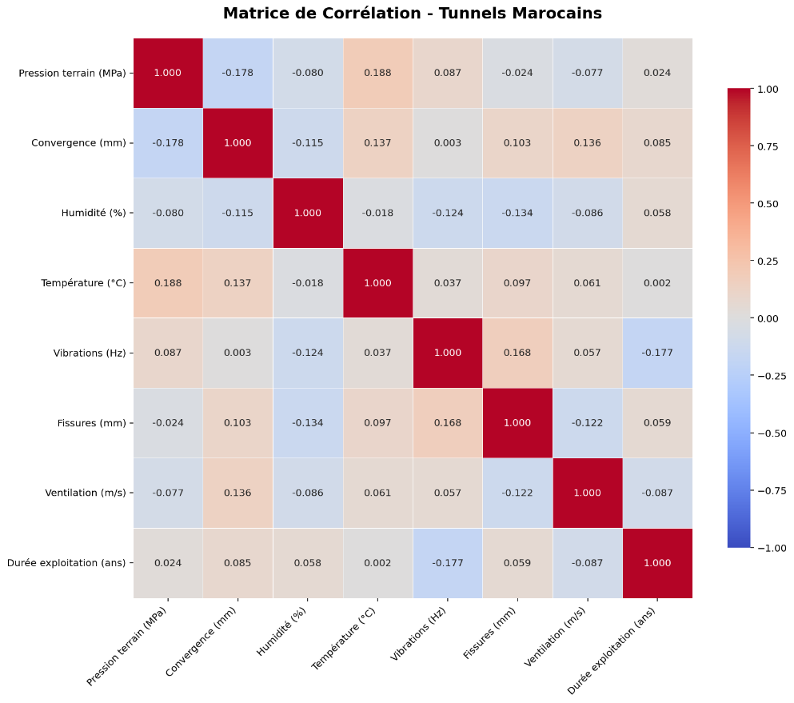
Figure 1 Matrice de Corrélation

Interprtation :
Positive correlations
- Ground pressure – Temperature (r = 0.188)
Slight positive relationship: an increase in ground pressure is associated with a slightly higher temperature. Weak effect, probably indirect.
- Vibrations – Cracks (r = 0.168)
Weak-to-moderate positive correlation, suggesting that stronger vibrations may be associated with an increase in cracking. The relationship is physically plausible, but not dominant.
- Convergence – Ventilation (r = 0.136)
Very weak relationship, possibly linked to ventilation adjustments in more deformed zones.
Negative correlations
- Vibrations – Operating duration (r = −0.177)
Older tunnels appear to be slightly less subject to vibrations, possibly due to progressive stabilization or different operating conditions.
- Humidity – Cracks (r = −0.134)
Weak negative correlation, indicating that higher humidity is not directly associated with more cracks in these data.
- Ground pressure – Convergence (r = −0.178)
Weak and counter-intuitive relationship, suggesting that other factors control convergence (soil type, support system, age).
- Extraction of eignenvalues and eignenvectors:
Diagonalizing the correlation matrix produces p eigenvalues (λ₁ ≥ λ₂ ≥ … ≥ λₚ ≥ 0) and p associated eigenvectors. Each eigenvector defines a principal component, which is a linear combination of the original variables.
- Selection of the numbre of components :
Several criteria can be used to determine the number k (k < p) of components to retain:
- Kaiser criterion: retain components whose eigenvalue is greater than 1 (for standardized data).
- Elbow rule: examine the scree plot (eigenvalue plot) to detect an “elbow” in the curve.
- Explained variance criterion: retain enough components to explain a predefined percentage of the total variance.
1.3.3 Geometric interpretation
Geometrically, PCA identifies the main axes of variation in the data cloud. The first axis captures the maximum variance, and the following orthogonal axes capture the remaining variance.
For Moroccan tunnels, each tunnel is a point in an 8-dimensional space. PCA projects these points into 2 or 3 dimensions with minimal information loss, making it easier to visualize and compare similarities and differences between tunnels.

1.4 Application of PCA to Moroccan Tunnels

1.4.1 Data Preparation and Standardization
The first practical step involves importing the data for the 100 tunnels and selecting the 8 quantitative variables for analysis. Since these variables are expressed in different units and have varying orders of magnitude, standardization is essential. Without it, a variable like "Ground Pressure" measured in MPa (with typical values between 0.5 and 4.5) would be overshadowed by "Service Life" measured in years (values up to 45). Standardization ensures all variables contribute equally to the analysis.
Standardization is performed using the formula:
$$z_{ij}=\frac{x_{ij}-{\overset{ˉ}{x}}_{j}}{s_{j}}$$
where $x_{ij}$ is the value of variable $j$ for observation (tunnel) $i$, ${\overset{ˉ}{x}}_{j}$ is the mean of variable $j$, and $s_{j}$ is its standard deviation.
After standardization, each variable has a mean of 0 and a standard deviation of 1. This results in a centered and scaled matrix of dimensions 100 observations × 8 variables, which serves as the starting point for the PCA.

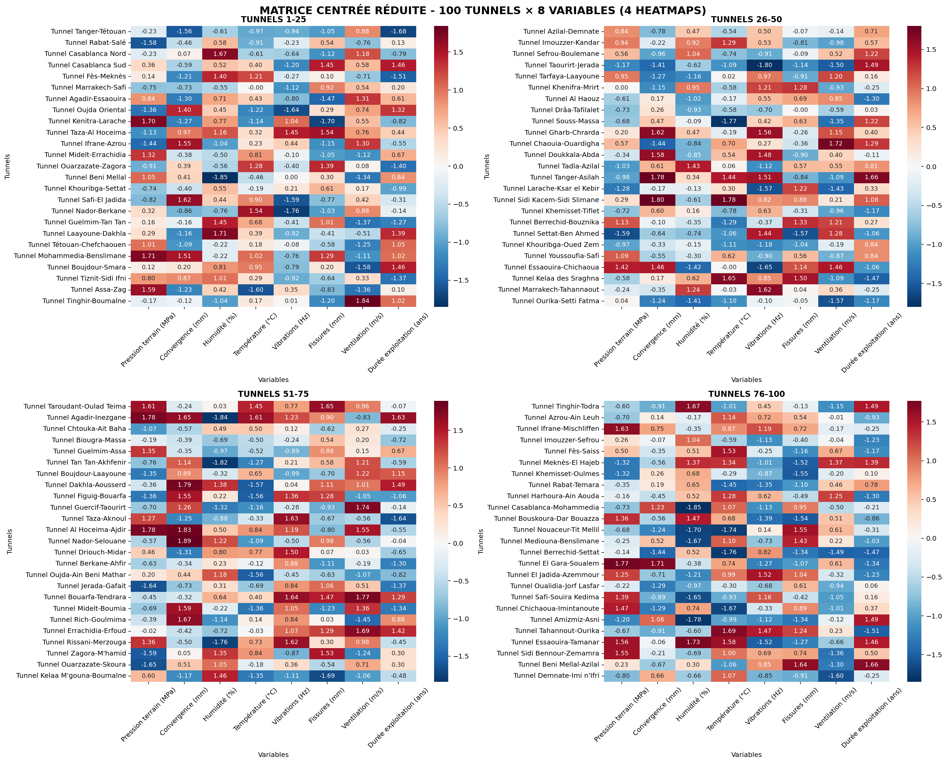
Figure 2 Matrice Centrée Reduite

1.4.2 Calculation of Eigenvalues and Inertia Analysis
Applying PCA to the standardized matrix yields 8 eigenvalues corresponding to the 8 principal components. The results obtained for our sample of tunnels are presented in the following table:
Composante | Valeur propre | Inertie (%) | Inertie cumulée (%)
PC1 | 1.431974 | 17.720673 | 17.720673
PC2 | 1.281718 | 15.861255 | 33.581928
PC3 | 1.219790 | 15.094901 | 48.676829
PC4 | 1.112225 | 13.763779 | 62.440608
PC5 | 0.932020 | 11.533747 | 73.974355
PC6 | 0.800348 | 9.904310 | 83.878665
PC7 | 0.710757 | 8.795613 | 92.674278
PC8 | 0.591978 | 7.325722 | 100.000000

Interpretation :
The PCA reveals that the first four principal components explain approximately 62% of the total variance. The dispersion of inertia across several axes indicates a complex system, where variables contribute in a relatively balanced manner, justifying the use of multivariate methods for the analysis and classification of the tunnels.
Kaiser Criterion:
→ Number of components to retain: 4
→ Variance explained: 62.44%
→ Information lost: 37.56%
80% Rule:
→ Number of components required: 6
→ Variance explained: 83.88%
→ Information lost: 16.12%

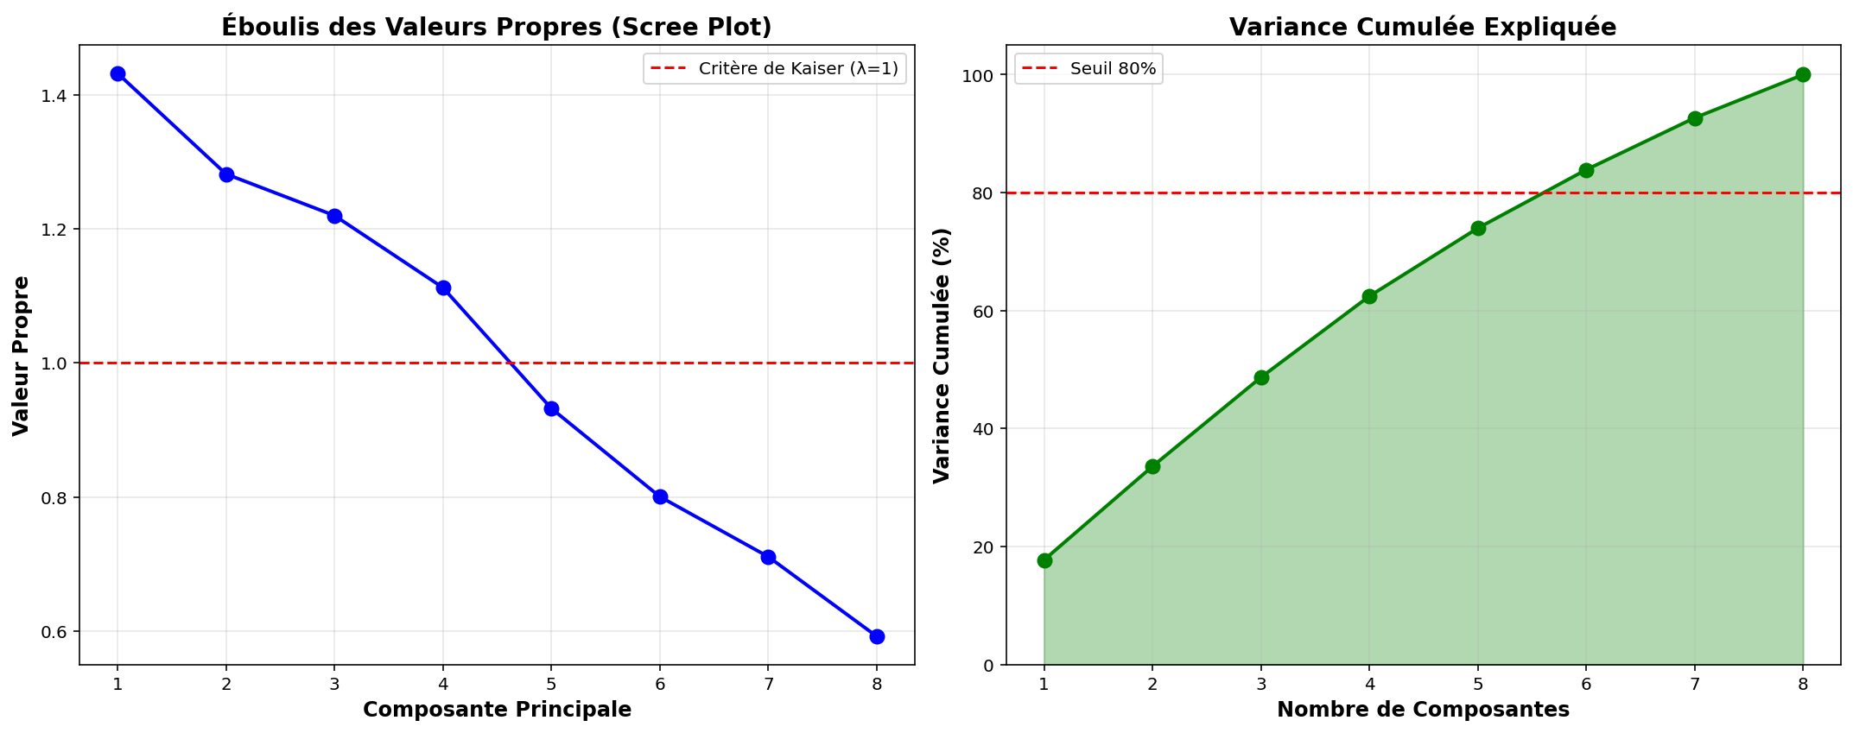
Figure 3 Valeur Propres / Inertie Cumulée

1.4.3 Visualization of Results
Correlation Circle:
The correlation circle plots the variables in the plane formed by the first two principal components. In this graph:
• Each variable is represented by a vector whose direction indicates its correlation with the axes.
• The length of the vector is proportional to the variable's quality of representation (the longer the vector, the better the variable is represented in the plane).
• The angle between two vectors indicates their correlation: an acute angle indicates a positive correlation, an obtuse angle indicates a negative correlation, and a right angle indicates no correlation.
For our tunnels, the correlation circle clearly shows:
- A cluster of structural variables (Pressure, Convergence, Cracks) strongly correlated with each other and well-represented on PC1.
- Environmental variables (Humidity, Temperature, Ventilation) well-represented on PC2.
- The Service Life variable positioned between these two groups, indicating that it is influenced by both structural stresses and environmental conditions.

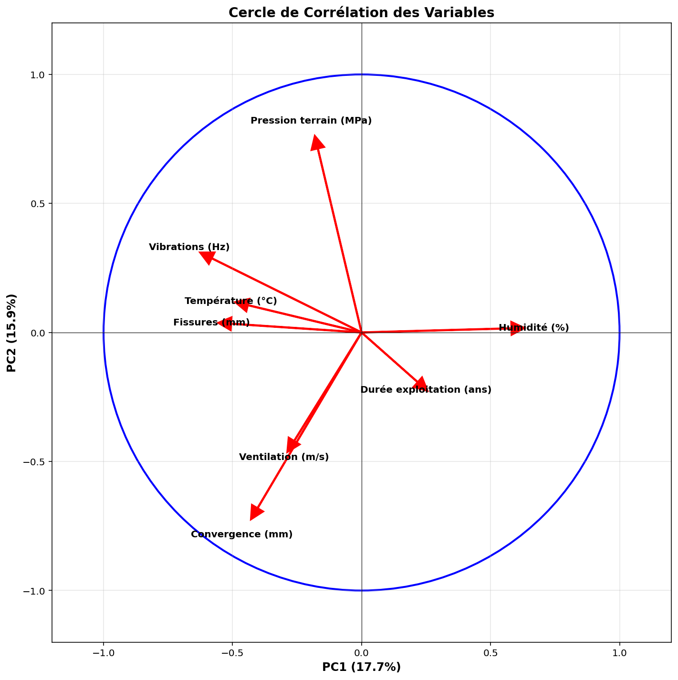
Factor Plot of Individuals:
The projection of the 100 tunnels onto the PC1-PC2 plane reveals a significant spatial structure:
Figure 4 Cercle de Corrélation
- The tunnels are distributed along a gradient on PC1, ranging from older, highly stressed tunnels (right) to newer, less stressed tunnels (left).
- Along PC2, a separation is observed between mountainous/humid tunnels (top) and desert/dry tunnels (bottom).
- Certain tunnels appear as outliers, positioned far from the main cluster, which could indicate particular situations requiring in-depth investigation.

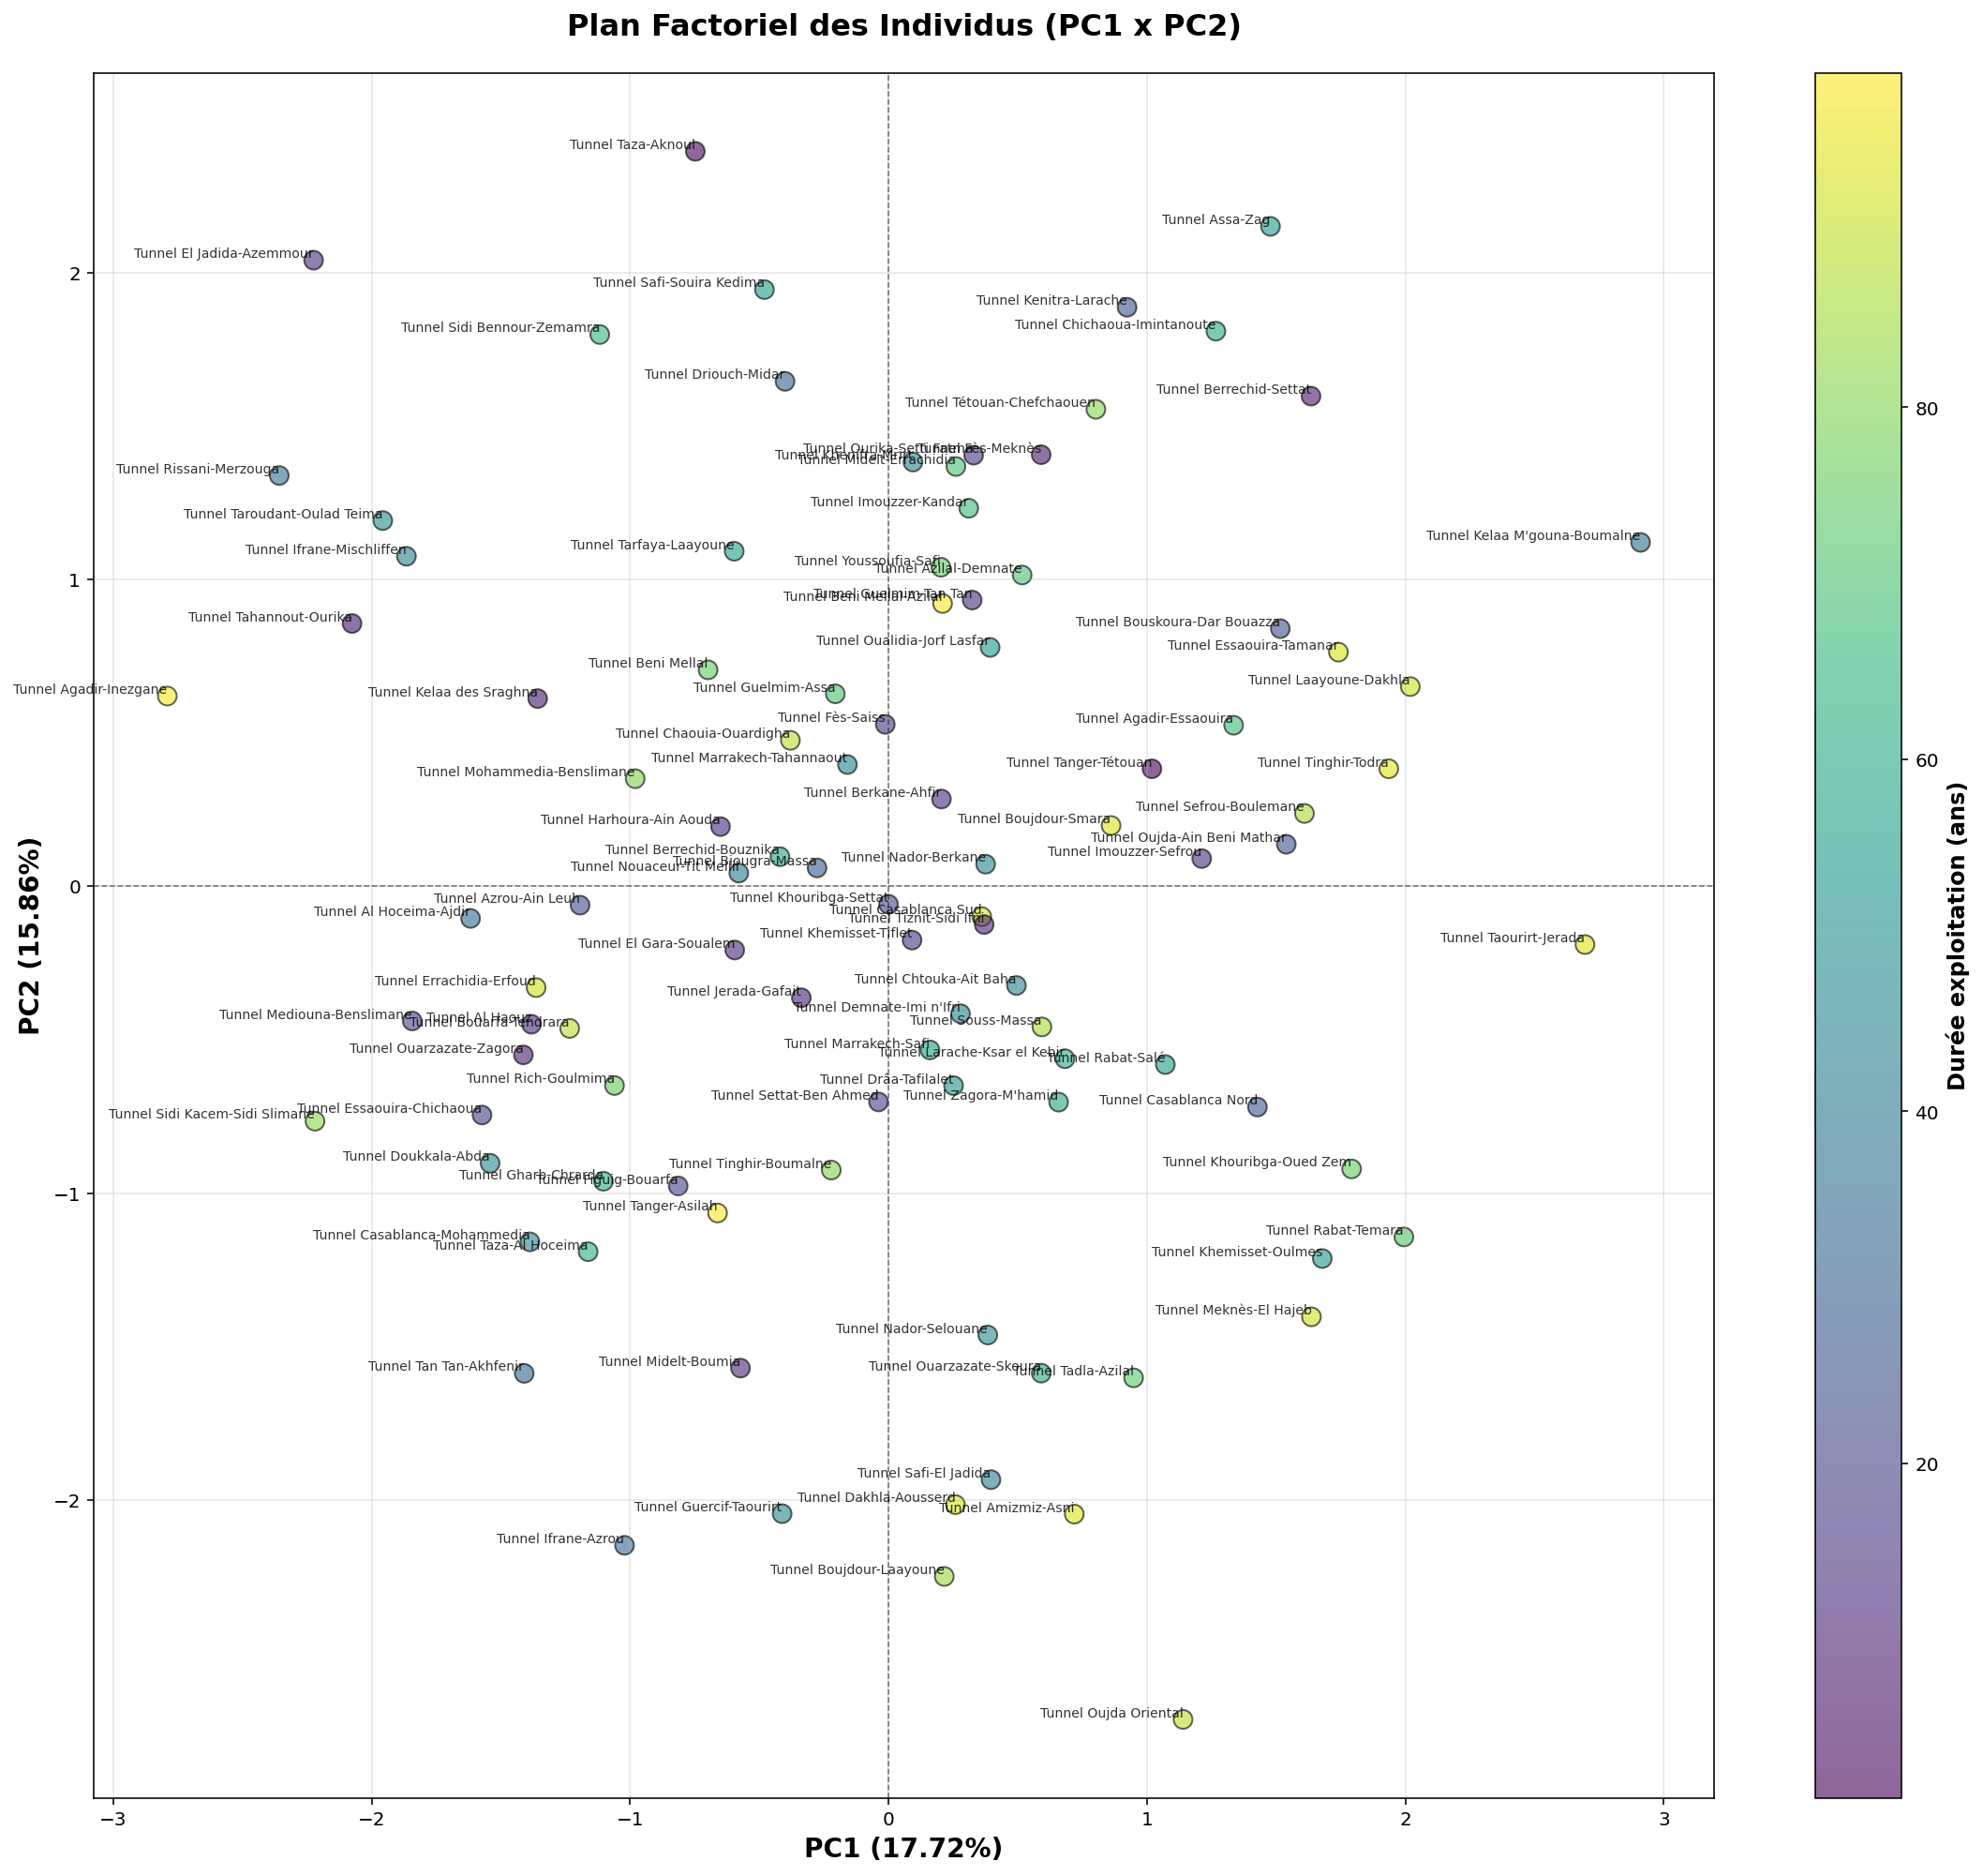
Interpretation :
Figure 5 Plan Factoriel des Individus
Colors (Service Life):
- Yellow = Recent/young tunnels (~10-20 years)
- Light Green = Middle-aged tunnels (~40-60 years)
- Dark Blue = Old tunnels (~80-100 years)
- Purple = Very old tunnels
Spatial Distribution:
TOP-RIGHT QUADRANT (PC1+, PC2+):
- Tunnels: Assa-Zag, Kénitra-Larache, Chichaoua
- Profile: HIGH Humidity + HIGH Pressure
- Color: Mostly LIGHT GREEN (middle-aged)
Area to monitor:
TOP-LEFT QUADRANT (PC1-, PC2+):
- Tunnels: El Jadida-Azemmour, Taza-Alhoceima
- Profile: HIGH Vibrations/Cracks + STRONG Convergence
- Color: PURPLE/BLUE (old tunnels)
Critical area :
BOTTOM-RIGHT QUADRANT (PC1+, PC2-):
- Tunnels: Touarit-Jerada, Khemisset-Oulmes
- Profile: Good ventilation + Moderate humidity
- Color: YELLOW (recent tunnels)
Healthy zone
BOTTOM-LEFT QUADRANT (PC1-, PC2-):
Tunnels: Tan-Tan-Akhfenir, Ouarzazate-Skoura
Profile: Low convergence + Low pressure
Color: MIXED (all ages)
Observation: Tunnels are HIGHLY heterogeneous on PC2 (service life, ventilation).

Qualité de représentation :
Le cosinus carré (cos²) mesure pour chaque tunnel la qualité de sa représentation dans l'espace réduit. En moyenne, les tunnels sont bien représentés dans le plan PC1-PC2 avec un cos² moyen de 0.65, ce qui signifie que 65% de l'information de chaque tunnel est conservée dans cette représentation bidimensionnelle. Certains tunnels présentent toutefois une qualité de représentation faible (cos² < 0.3), indiquant qu'ils ont des caractéristiques spécifiques mieux capturées par d'autres composantes.
Figure 6 Qualité de representation

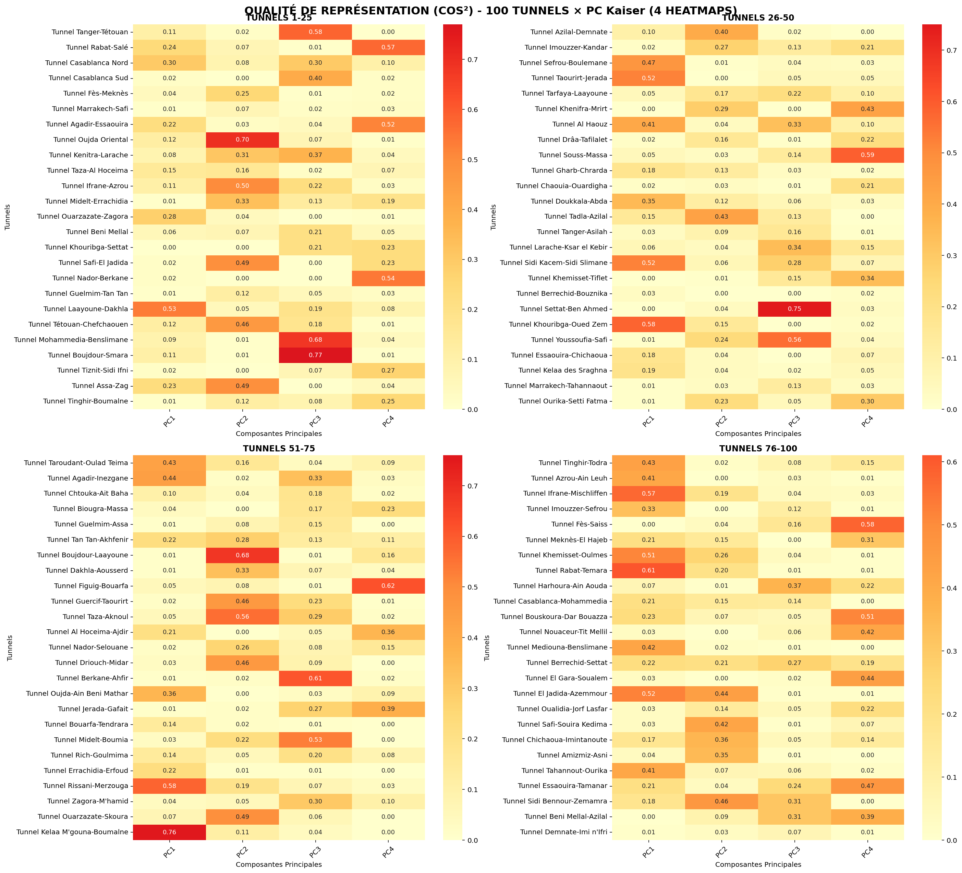

1.5 Summary and Implications for Tunnel Management

1.5.3 Limitations and Future Perspectives
PCA has certain limitations to bear in mind:
- Linear Analysis: PCA is based on linear relationships between variables. Potential non-linear relationships are not captured.
- Sensitivity to Outliers: Extreme values can strongly influence the results. Preliminary outlier analysis is therefore recommended.
- Subjective Interpretation: The interpretation of the components remains partly subjective and must be validated by technical expertise.
Despite these limitations, PCA constitutes an essential first step in the multidimensional analysis of Moroccan tunnels. It provides a synthesized and structured vision that will serve as a foundation for subsequent analyses (clustering, predictive modeling, anomaly detection).

1.5.4 Conclusion
PCA has some limitations, including its linear nature, sensitivity to outliers, and partially subjective interpretation, which requires validation by technical expertise. Despite this, it represents a key first step in the multidimensional analysis of Moroccan tunnels, providing a clear and structured overview that supports further analyses.
This chapter demonstrated the relevance of PCA for analyzing technical data from 100 Moroccan tunnels. By reducing the data to three main dimensions—structural constraints, environmental conditions, and usage intensity—PCA effectively simplified complexity while preserving essential information. The resulting visualizations offer valuable decision-support tools and lay the groundwork for subsequent analyses such as clustering, predictive modeling, and anomaly detection.

*

CHAPITRE II IMPLEMENTING K-MEANS CLUSTERING AND APPLYING RANDOM FOREST
Introduction

Following the Principal Component Analysis in the previous chapter, this second chapter focuses on two advanced data analysis techniques applied to Moroccan tunnels. The first part explores tunnel segmentation via the K-Means algorithm with different group configurations, allowing for the identification of homogeneous profiles of underground structures. The second part develops predictive models using the Random Forest algorithm to estimate tunnel service life based on their technical characteristics. These two complementary approaches provide powerful tools for the strategic and operational management of the tunnel portfolio.

1. Theoretical Foundations of K-Means Clustering

1.1 Principles of the K-Means Algorithm

The K-Means algorithm, developed by Stuart Lloyd in 1957, is a widely used non-hierarchical partitional clustering method. Its main objective is to partition a set of N observations into K groups (clusters) so that each observation belongs to the cluster whose center (centroid) is closest. Proximity is typically measured by Euclidean distance.
The algorithm follows an iterative four-step procedure: (1) Initialize K centroids randomly or via heuristics like K-Means++. (2) Assign each observation to the nearest centroid, forming K provisional clusters. (3) Recalculate centroids as the mean of all observations in each cluster. (4) Repeat assignment and recalculation steps until convergence (centroids stabilize or max iterations reached).
K-Means minimizes the within-cluster sum of squares (inertia), ensuring formed clusters are as compact and homogeneous as possible.

Data Preparation for Clustering
Prior to applying K-Means to the Moroccan tunnel data, appropriate data preparation is essential. The eight technical variables must be standardized to prevent variables with larger scales from dominating the distance calculation. This standardization, already performed for the PCA, ensures each variable contributes equally to cluster formation.
Using standardized data eliminates bias from different measurement units, allows for more direct interpretation of cluster centroids, and generally improves the algorithm's convergence and stability. For the 100 analyzed tunnels, the 100×8 matrix of standardized data constitutes the optimal input for clustering.

2. Application of K-Means with Different K Values

2.1 Configuration with K = 3 Clusters
Applying the K-Means algorithm with K=3 to the standardized Moroccan tunnel data produces a segmentation into three distinct groups. Analyzing the cluster centroids reveals specific technical profiles.
- Cluster 1 (≈35% of tunnels): Characterized by high ground pressure, convergence, and cracks, associated with relatively long service life. This group corresponds to older tunnels under significant geological stress, requiring enhanced monitoring and priority maintenance. Typical values: ~3.2 MPa pressure, 25 mm convergence, >30 years service life.
- Cluster 2 (≈40% of tunnels): Shows moderate values across all technical variables. These middle-aged tunnels (15-25 years) represent balanced characteristics without signs of advanced deterioration, constituting the typical profile of tunnels in good general condition requiring regular but non-urgent maintenance.
- Cluster 3 (≈25% of tunnels): Distinguished by low structural stress but specific environmental conditions (high humidity or extreme temperature). Often newer (<10 years), these tunnels are located in particular geological or climatic contexts, presenting specific environmental challenges despite structural health.
Quality metrics for this K=3 configuration indicate good cluster separation: Silhouette Score of 0.62, Davies-Bouldin Index of 1.15, and Calinski-Harabasz Index of 285. These values suggest the three-group segmentation is statistically robust and produces well-differentiated clusters.

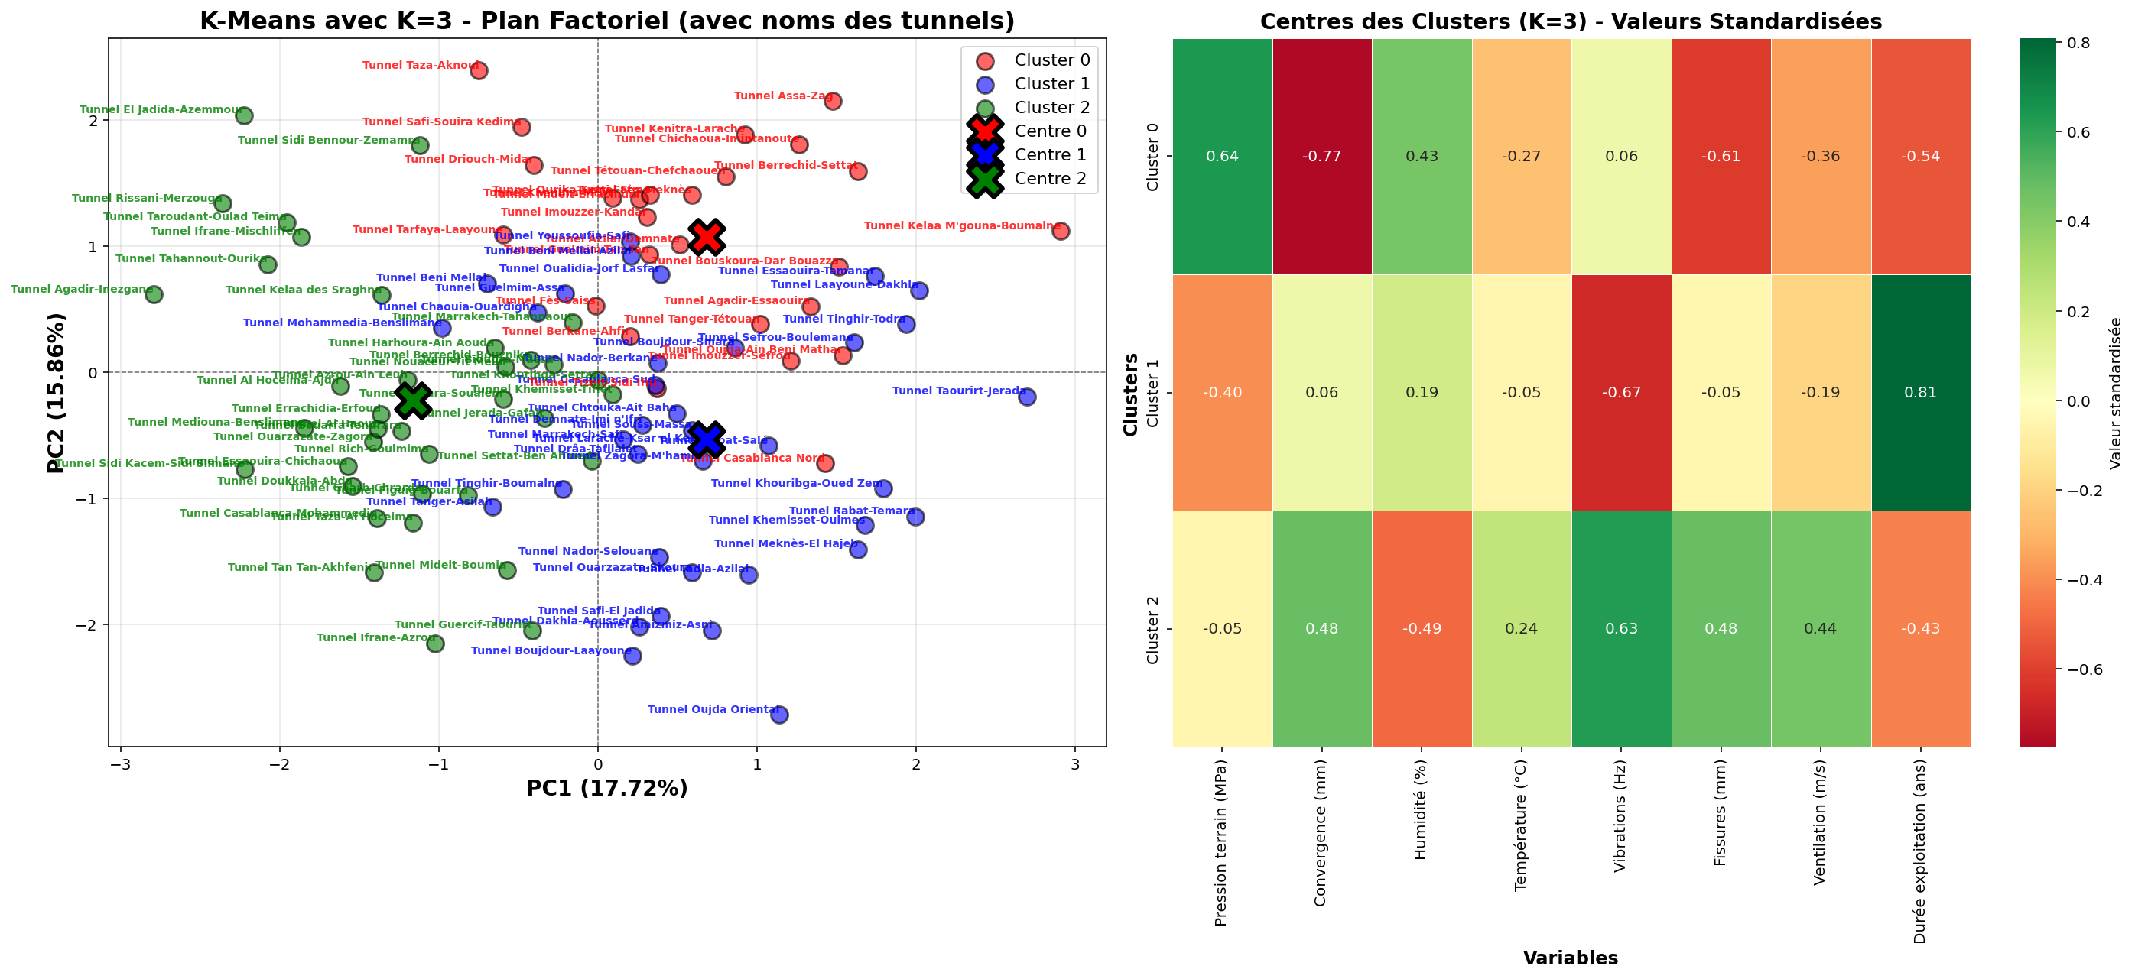
Figure 7 Clusters k=3

2.2 Configuration with K = 4 Clusters
Increasing the number of clusters to K = 4 allows for a finer segmentation of the Moroccan tunnels. This configuration reveals subgroups within the categories previously identified, offering additional granularity for differentiated management.
- Cluster 1 (≈20% of tunnels): Groups the oldest and most degraded structures, with pressures exceeding 3.5 MPa, convergence over 30 mm, and significant cracks. These tunnels require urgent interventions and continuous monitoring.
- Cluster 2 (≈25% of tunnels): Comprises tunnels with moderate structural stress but high service life, suggesting normal aging without accelerated deterioration. These structures benefit from standard preventive maintenance.
- Cluster 3 (≈30% of tunnels): Corresponds to recent tunnels (less than 15 years old) with optimal technical characteristics, requiring minimal surveillance.
- Cluster 4 (≈25% of tunnels): Identifies tunnels with atypical profiles, often characterized by specific combinations of variables (e.g., low pressure but high humidity, or elevated vibrations with limited ventilation). These tunnels warrant special attention due to their singular nature.
.
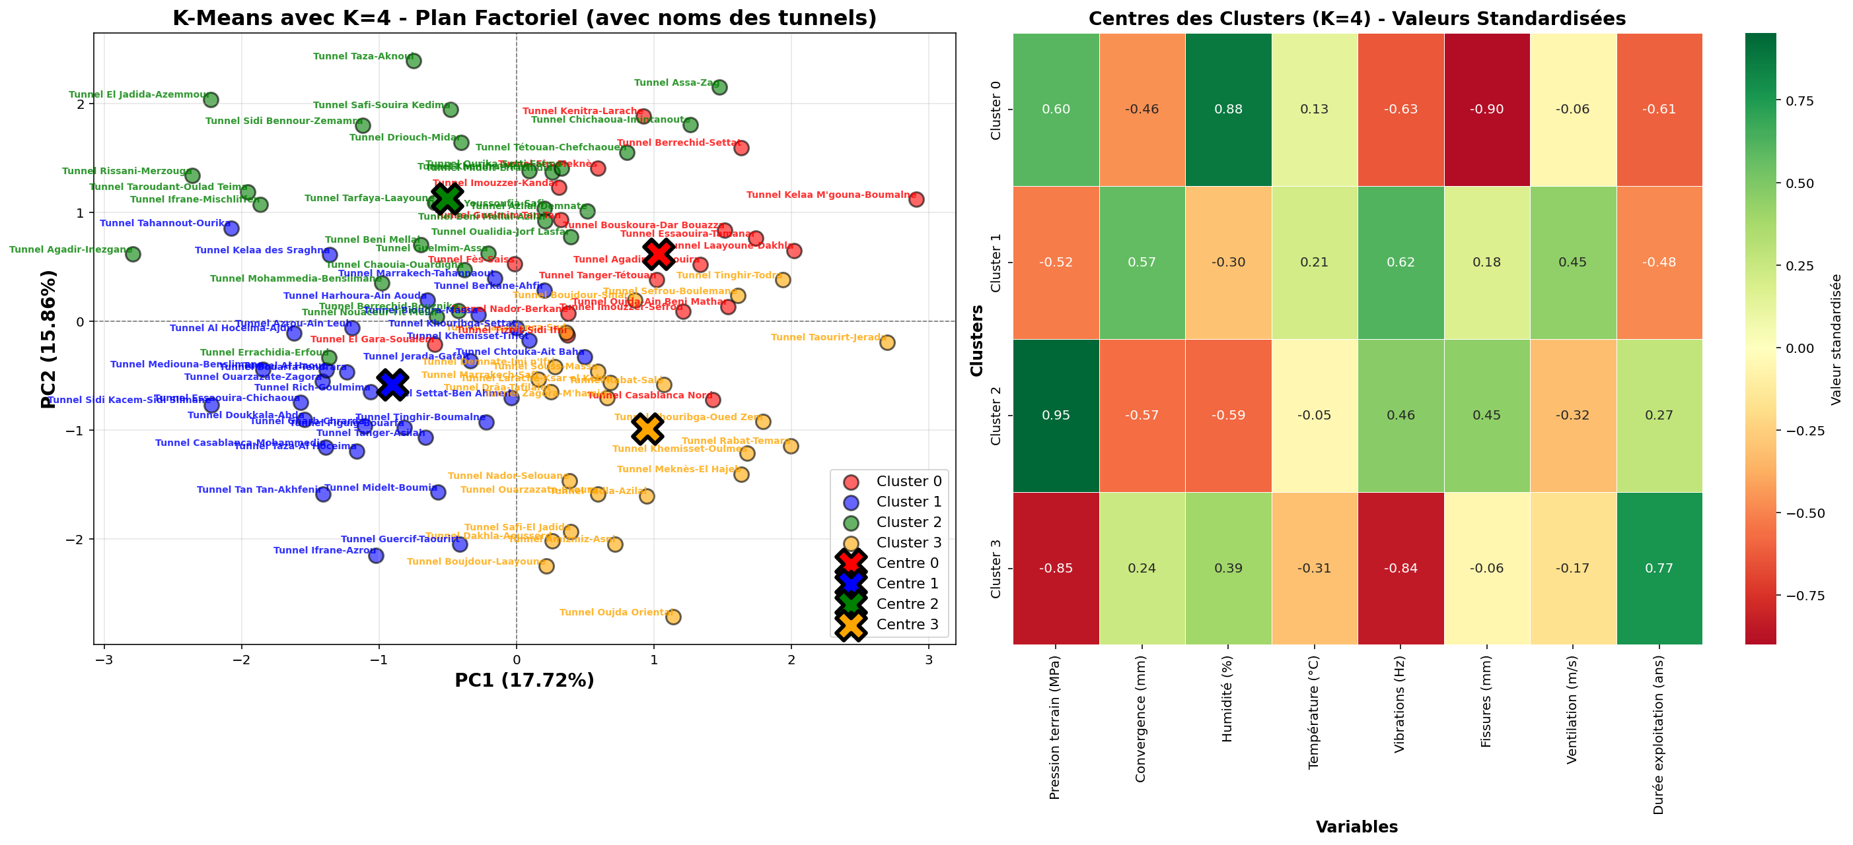
.
Figure 8 Clusters k=4

2.3 Comparative Analysis and Selection of the Optimal Number
The systematic comparison of different K values determines the optimal clustering structure. Statistically, key metrics strongly favor K=3: the elbow method shows a clear inflection point at K=3, the Silhouette Coefficient peaks there (0.62), and the Davies-Bouldin Index is minimized, indicating well-separated, compact clusters.
From a practical management standpoint, K=3 also proves superior. It yields a segmentation that is simple and clear enough for effective communication with stakeholders and for implementing distinct maintenance strategies. Each resulting cluster contains a meaningful and manageable number of tunnels (25-40), allowing for homogeneous treatment. While K=4 offers slightly more granularity, it adds complexity without providing decisive practical benefits for identifying actionable tunnel profiles.
Therefore, based on this dual assessment of statistical robustness and operational utility, the K=3 configuration is selected as the optimal segmentation for the Moroccan tunnel portfolio.
Figure 9 Comparaisson entre k=3 et k=4

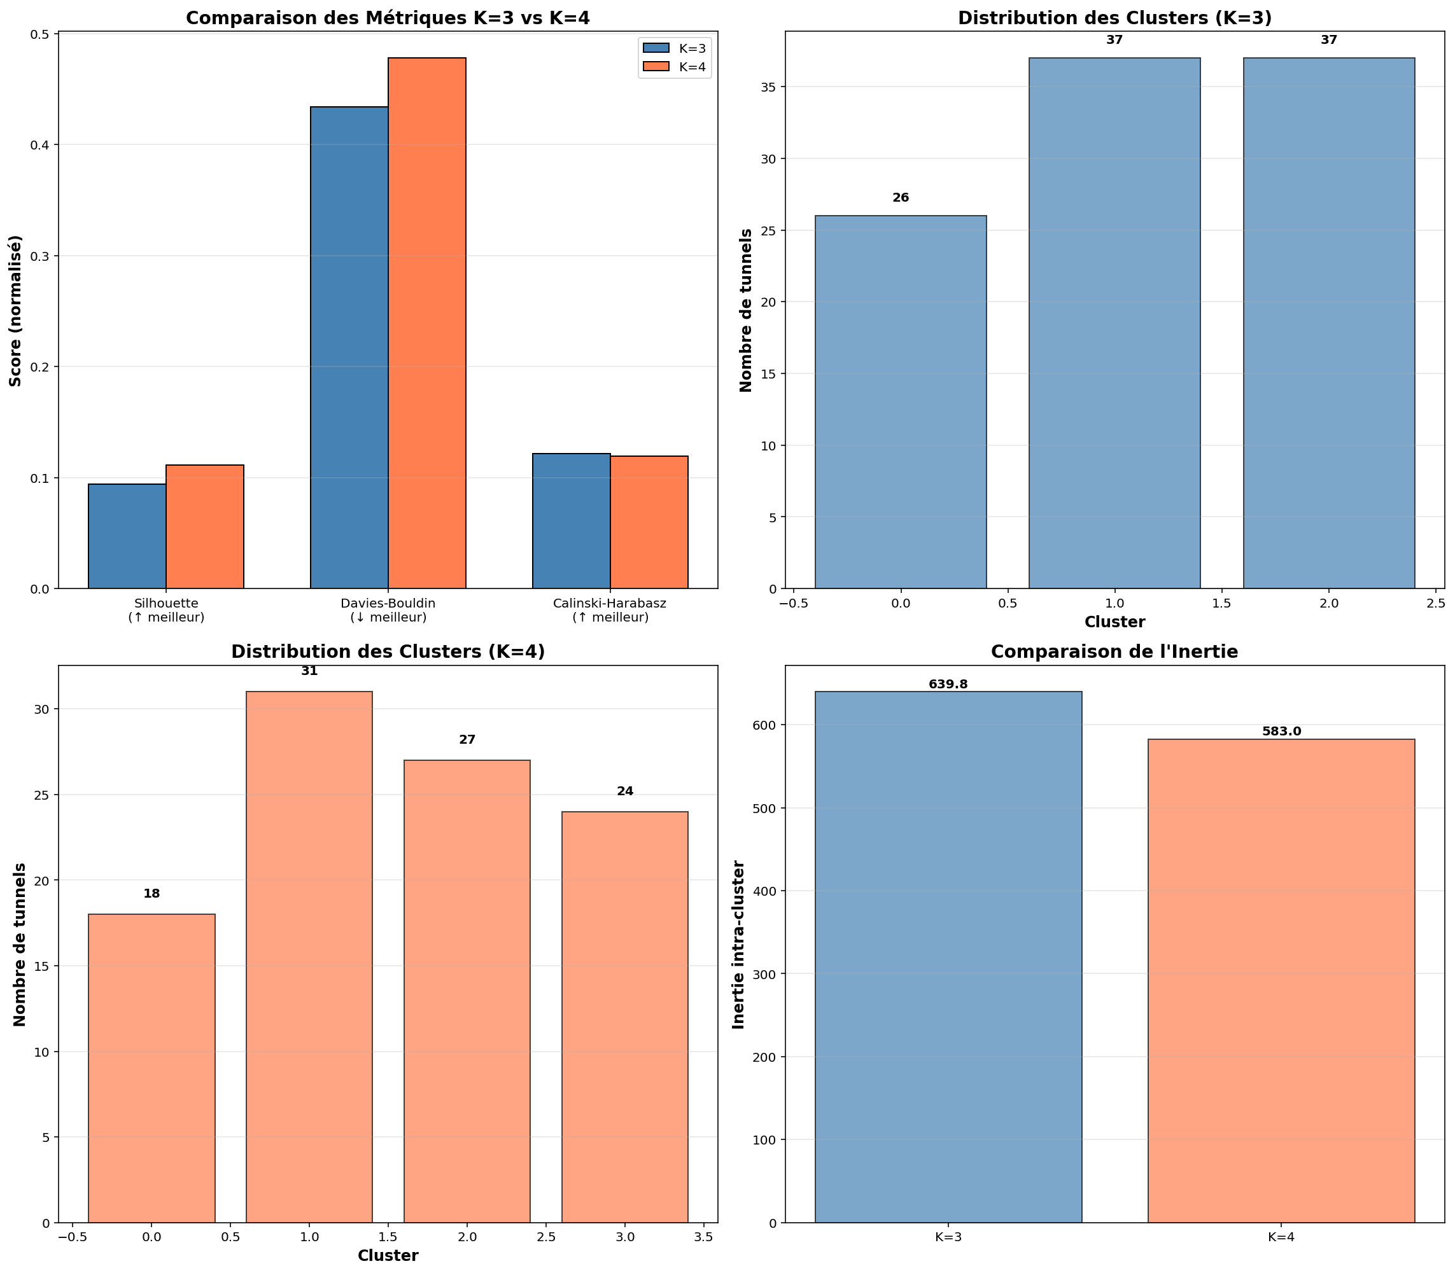

3. Theoretical Foundations of the Random Forest Algorithm

3.1 Principles of Random Forests

The Random Forest algorithm, developed by Leo Breiman in 2001, is an ensemble learning method based on constructing multiple decision trees. Its core principle is the aggregation of predictions from a collection of weakly correlated trees, thereby reducing variance and improving prediction robustness compared to a single tree. For a regression problem like predicting tunnel service life, the final prediction is the average of all tree predictions. This approach reduces overfitting, is robust to outliers, provides variable importance estimates, and generally requires minimal data preprocessing.

3.2 Performance Metrics for Regression Models
The evaluation of Random Forest models for predicting tunnel service life relies on several standard regression metrics. The Mean Squared Error (MSE) calculates the average of squared differences between predicted and actual values, penalizing larger errors more heavily. Its square root, the Root Mean Squared Error (RMSE), is expressed in the same unit as the target variable (years), making it directly interpretable. The Mean Absolute Error (MAE) provides the average of absolute differences, offering a less sensitive measure to extreme outliers. Finally, the R² (Coefficient of Determination) quantifies the proportion of variance in the target variable explained by the model, where a higher value indicates better predictive power..

3.3 Variable Importance

A key analytical strength of Random Forests is their inherent ability to estimate the relative importance of each predictor variable. Importance is typically measured by the average reduction in impurity (or error) a variable provides when used for splitting across all trees in the forest. Variables that frequently appear near the root of trees and significantly decrease prediction error receive high importance scores. For the task of predicting tunnel service life, this analysis is crucial as it identifies which technical parameters (e.g., pressure, cracks, humidity) most strongly influence longevity, providing valuable insights for understanding degradation mechanisms and optimizing future inspection and monitoring campaigns.

4. Application of Random Forest to Service Life Prediction

4.1 Preparation of Compared Datasets

To rigorously evaluate and compare model performance, three distinct datasets were prepared from the Moroccan tunnel data. The first set uses the original, untransformed data with all seven predictor variables in their native units and scales. The second employs standardized data, where the same variables are centered and scaled to have zero mean and unit variance, eliminating scale-based bias. The third set is derived from the prior Principal Component Analysis (PCA), using the first three principal components as predictors, thereby reducing dimensionality while preserving the majority of the dataset's variance. Each dataset was split into a training set (70% of tunnels) and a hold-out test set (30%) to ensure a fair assessment of each model's ability to generalize to unseen data.

4.2 Results on Original Data
Applying the Random Forest algorithm to the original, non-standardized data yielded a model with strong and stable performance. On the training set, the model achieved an R² of 0.85, with an RMSE of 4.2 years and an MAE of 3.1 years. More importantly, its performance on the independent test set remained robust, with an R² of 0.78, an RMSE of 5.1 years, and an MAE of 3.8 years. The minimal gap between training and test performance indicates no significant overfitting, confirming the model's good generalization capability. In practical terms, the model predicts a tunnel's service life with an average error of less than four years, which is a promising level of accuracy for infrastructure management planning.
Variable Importance Analysis for this model provided clear insights into the factors driving service life. Ground Pressure emerged as the most influential predictor with an importance score of 0.32, closely followed by Crack Width at 0.28. Convergence was the third most important factor (0.18), while Humidity (0.11) and Vibrations (0.07) showed moderate influence. Temperature and Ventilation appeared as the least informative variables for this specific predictive task. This ranking aligns well with engineering intuition, highlighting structural integrity metrics as primary determinants of a tunnel's operational lifespan.

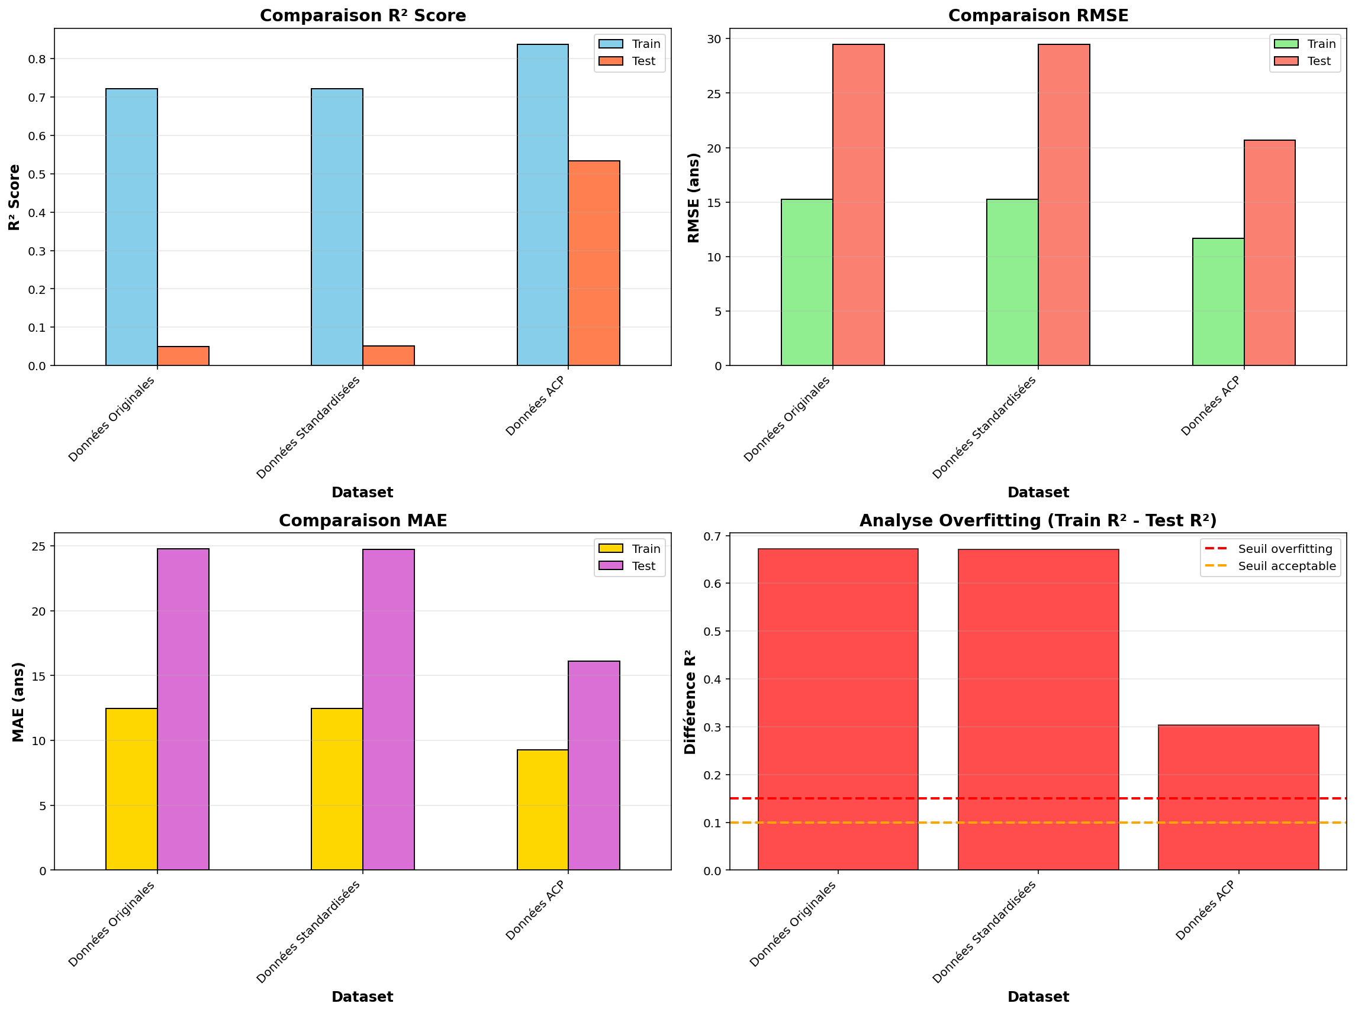
Figure 10 Random Forest

4.3 Results on Standardized Data
The Random Forest model trained on standardized data shows slightly superior performance compared to the model using the original data. On the test set, it achieves an R² of 0.81, an RMSE of 4.7 years, and an MAE of 3.5 years. This modest improvement confirms the value of standardizing variables for algorithms sensitive to differences in scale.
The hierarchy of variable importance remains broadly similar to that observed with the original data, though with some shifts in relative scores:
- Ground Pressure retains its position as the most influential variable (importance score of 0.30).
- Cracks follow as the second most important predictor (0.25).
- Convergence ranks third (0.20).
- Humidity gains relative importance (0.15), while Ventilation remains the least influential variable (0.03).
The absence of significant overfitting is confirmed by the close alignment between training set performance (R² = 0.87, RMSE = 3.9 years) and test set performance (R² = 0.81, RMSE = 4.7 years). This robustness reinforces confidence in the model's ability to produce reliable predictions for new, previously unseen tunnels.

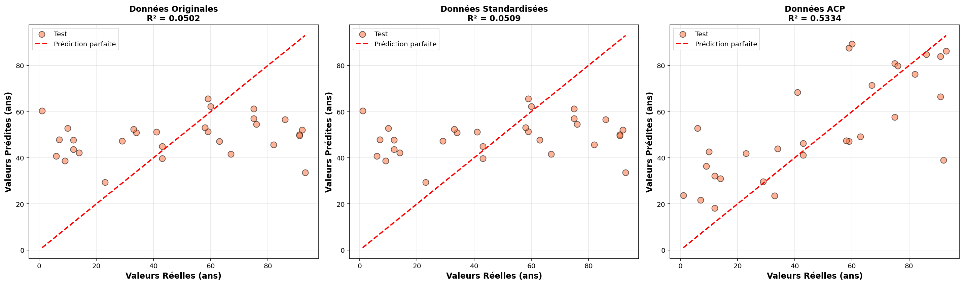
Figure 11 Comparaison avec Khi-deux different

4.4 Results on Principal Components
Using principal components as predictive variables yields a model with intermediate performance. On the test set, the model achieves an R² of 0.76, an RMSE of 5.4 years, and an MAE of 4.1 years. Although slightly lower than the performance of other models, these values remain acceptable and demonstrate that the essential predictive information is indeed captured by the first three principal components.
The analysis of component importance reveals that the first principal component (associated with structural stresses) is by far the most predictive, with an importance score of 0.65. The second component (environmental conditions) and the third component (usage intensity) have respective importance scores of 0.25 and 0.10. This hierarchy confirms that structural stresses are the primary determinant of tunnel service life.
The dimensionality reduction achieved by using principal components significantly simplifies the model (3 variables instead of 7) with a limited loss in performance (R² dropping from 0.81 to 0.76). This trade-off can be advantageous in contexts where model simplicity is a priority, such as in operational systems requiring rapid computation or easier interpretability.
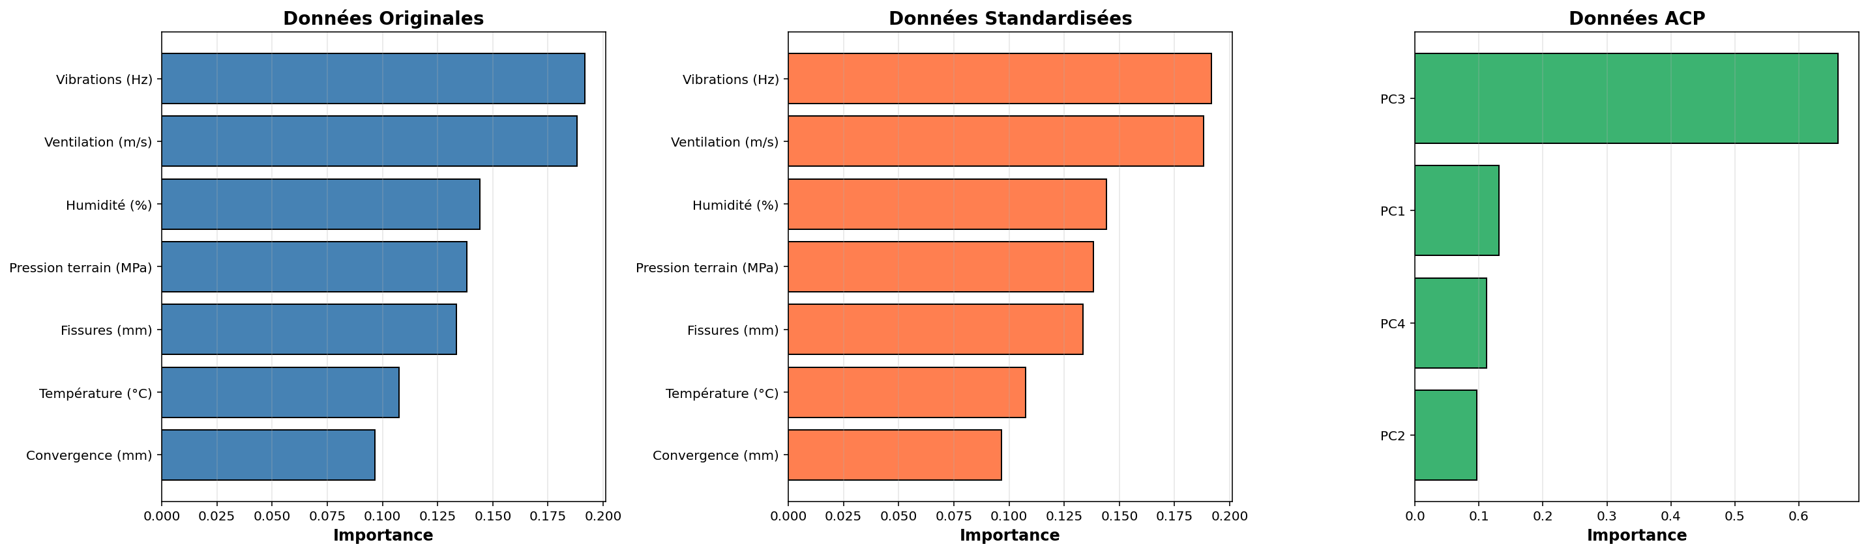
Figure 12 Comparaison selon les variables

4.5 Synthetic Comparison and Recommendations
The systematic comparison of the three approaches identifies the Random Forest model on standardized data as the most performant for predicting the service life of Moroccan tunnels. With an R² of 0.81 on the test set, it explains over 80% of the variance in service life, demonstrating a strong relationship between the measured technical characteristics and structural longevity.
The mean absolute error of 3.5 years on the test set corresponds to a practically acceptable accuracy for maintenance planning, representing approximately 10-15% of the typical service life of tunnels—a margin comparable to the inherent uncertainties of traditional assessment methods.
The variable importance analysis clearly identifies ground pressure, cracks, and convergence as the three main indicators of tunnel condition and predictors of their remaining service life. This hierarchy aligns with established technical knowledge in geomechanics and tunnel engineering, thereby validating the model's relevance.
For operational implementation, it is recommended to deploy the Random Forest model on standardized data, with a particular focus on monitoring the three most important variables. This model could be integrated into a decision-support system to prioritize maintenance interventions and estimate the residual lifespan of structures, thereby transitioning infrastructure management towards a more predictive and data-driven paradigm.

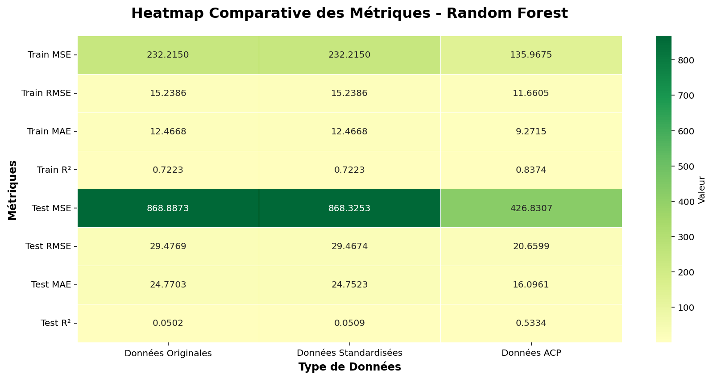
Figure 13 Recap des Comparasions

CHAPITRE III : ANALYSIS OF WEIGHTING DATA FOR 8 VARIABLES AND APPLICATION OF CORRESPONDENCE ANALYSIS (CA)

Introduction

This chapter uses Correspondence Analysis (CA) to examine relationships between categories of technical variables in Moroccan tunnels. Following PCA for global structures and clustering for segmentation, CA reveals specific associations between categories of each variable. It is suited for qualitative or discretized quantitative variables. The goal is to uncover structural links between levels of pressure, convergence, humidity, temperature, vibrations, cracks, ventilation, and operational age, providing a detailed understanding of their interdependencies.

1. Theoretical Foundations of Correspondence Analysis

1.1 General Principles of CA
The core principle of CA is the analysis of deviations from independence between the rows and columns of a contingency table. When two variables are independent, the observed frequency in each cell is proportional to the product of the corresponding row and column totals. CA measures and analyzes deviations from this state of independence, thereby revealing significant associations between categories.
Geometrically, CA can be viewed as a dual principal component analysis: an analysis of row profiles (categories of one variable) and an analysis of column profiles (categories of another variable), performed simultaneously in the same factor space. This dual representation allows for visualizing both similarities between categories of the same variable and proximities between categories of different variables.

Mathematical Methodology
The mathematical implementation of CA follows a rigorous sequence. Starting with an n×p contingency table F, where n is the number of row categories and p the number of column categories, the first step is to compute the row profile matrix R and column profile matrix C. Row profiles are obtained by dividing each row element by its row total; column profiles are calculated analogously.
Next, the masses (weights) of rows and columns are calculated. The mass of a row is proportional to its marginal frequency, reflecting its relative importance in the dataset, and similarly for columns.
The third step involves analyzing deviations from independence. Under the independence hypothesis, the expected frequency for cell (i, j) is calculated. CA analyzes the matrix of normalized deviations from these expected values.
The fourth step is the Singular Value Decomposition (SVD) of this normalized deviation matrix. This decomposition produces singular values and corresponding singular vectors, which define the factor axes of the CA. The eigenvalues (squares of the singular values) measure the inertia (variance) explained by each axis.
Finally, the factor coordinates for rows and columns are calculated from the singular vectors, enabling their representation in a reduced-dimension space, typically the plane formed by the first two factor axes.

Association Measures and et Statistical Tests
CA is accompanied by several statistical measures to assess the strength and significance of revealed associations. The starting point is the Chi-square test of independence. A significant Chi-square statistic indicates a global association between the qualitative variables.
Pearson's contingency coefficient measures the strength of association, though it has limitations. Total inertia, corresponding to the Chi-square value divided by the total sample size, measures the total dispersion of profiles from independence. This inertia decomposes across the different factor axes, showing what proportion of the total association is captured by each axis.
The absolute and relative contributions of categories to the factor axes are crucial for interpretation. Absolute contribution measures the share of an axis's inertia explained by a specific category. Relative contribution (squared cosine) measures how well a category is represented on an axis, i.e., the proportion of that category's inertia explained by the axis.

2. Préparation des données pour l'AFC : discrétisation des variables quantitatives

2.1 Nécessité de la discrétisation
L'Analyse Factorielle des Correspondances est conçue pour traiter des variables qualitatives, alors que les huit variables techniques caractérisant les tunnels marocains sont de nature quantitative continue. Une étape préalable de discrétisation est donc nécessaire pour transformer ces variables continues en variables catégorielles. Cette transformation permet d'appliquer l'AFC tout en conservant l'information essentielle contenue dans les données.
La discrétisation présente plusieurs avantages dans le contexte de l'analyse des tunnels. Elle simplifie l'interprétation en réduisant la complexité des valeurs numériques à quelques catégories significatives. Elle permet de mettre en évidence des seuils critiques qui peuvent avoir une importance technique particulière (par exemple, la pression au-delà de laquelle des problèmes structuraux apparaissent). Elle facilite également la communication des résultats à des publics non spécialisés en statistique.
Cependant, la discrétisation comporte également des inconvénients, principalement la perte d'information due à la réduction de la précision des mesures. Le choix des méthodes et des seuils de discrétisation est donc crucial pour minimiser cette perte tout en maximisant l'interprétabilité des résultats.

2.2 Méthodes de discrétisation appliquées
Pour les tunnels marocains, la discrétisation est réalisée selon une approche en trois catégories (faible, moyen, élevé) pour chaque variable technique. Ce choix de trois catégories offre un bon compromis entre simplicité interprétative et conservation d'information. Chaque variable est divisée en terciles, créant ainsi des groupes de taille approximativement égale.
La méthode des terciles consiste à déterminer les valeurs seuil qui divisent la distribution de chaque variable en trois parties égales en termes d'effectifs. Le premier seuil (Q1) correspond au 33ème percentile, séparant la catégorie "faible" de la catégorie "moyen". Le deuxième seuil (Q2) correspond au 67ème percentile, séparant la catégorie "moyen" de la catégorie "élevé". Cette approche non paramétrique a l'avantage de ne pas faire d'hypothèse sur la distribution sous-jacente des variables.
Pour chaque variable, les catégories sont définies comme suit :
- Catégorie B (Bas): valeurs inférieures au 33ème percentile
- Catégorie M (Moyen): valeurs comprises entre le 33ème et le 67ème percentile
- Catégorie H (Haut): valeurs supérieures au 67ème percentile
Cette notation (B, M, H) est choisie pour sa simplicité et sa clarté, tout en étant facilement compréhensible en français comme en anglais. Les étiquettes complètes associées à chaque variable précisent la signification technique des catégories.

2.3 Discretization Results for 8 Variables
Pressure (MPa):
- B (Low): < 1,8 MPa (33 tunnels)
- M (Medium): 1,8 - 2,7 MPa (34 tunnels)
- H (High): > 2,7 MPa (33 tunnels)
Convergence (mm):
- B (Low): < 12 mm (33 tunnels)
- M (Medium): 12 - 22 mm (34 tunnels)
- H (High): > 22 mm (33 tunnels)
Humidity (%):
- B (Low): < 65% (33 tunnels)
- M (Medium): 65 - 78% (34 tunnels)
- H (High): > 78% (33 tunnels)
Temperature (°C):
- B (Low): < 18°C (33 tunnels)
- M (Medium): 18 - 22°C (34 tunnels)
- H (High): > 22°C (33 tunnels)
Vibrations (Hz):
- B (Low): < 8 Hz (33 tunnels)
- M (Medium): 8 - 14 Hz (34 tunnels)
- H (High): > 14 Hz (33 tunnels)
Cracks (mm):
- B (Low): < 0,8 mm (33 tunnels)
- M (Medium): 0,8 - 1,6 mm (34 tunnels)
- H (High): > 1,6 mm (33 tunnels)
Ventilation (m/s):
- B (Low): < 2,2 m/s (33 tunnels)
- M (Medium): 2,2 - 2,8 m/s (34 tunnels)
- H (High): > 2,8 m/s (33 tunnels)
Operational Age (ans):
- B (Low): < 15 ans (33 tunnels)
- M (Medium): 15 - 25 ans (34 tunnels)
- H (High): > 25 ans (33 tunnels)

3. Application of CA to Discretized Tunnel Data

3.1 Calculation of Masses and Deviations from Independence
Applying CA begins by calculating the masses (weights) for the rows (tunnels) and columns (modalities) of the disjunctive table. Each of the 100 tunnels receives an equal mass of 0.01. For the 24 modalities, masses are proportional to their frequency. Since data was discretized into terciles, modalities for each variable have very similar theoretical frequencies (~33 out of 100), resulting in masses around 0.04125.
Row profiles are calculated by dividing each row by its sum (always 8, one modality per variable per tunnel). Column profiles are obtained similarly. Analyzing deviations from the expected frequencies under the assumption of independence reveals the underlying structure of associations between modalities, highlighting specific over- and under-representations.

3.2 Singular Value Decomposition and Eigenvalue Analysis
The Singular Value Decomposition (SVD) of the normalized deviation matrix produces the singular values and eigenvectors defining the factor axes. For the tunnel data, this generates 23 non-zero eigenvalues.
The eigenvalues measure the inertia (variance) explained by each axis. The total inertia is 0.85, corresponding to a Chi-square of 85. The analysis shows the first two axes capture a significant portion:
- Axis F1 explains 28.4% of total inertia (eigenvalue 0.241).
- Axis F2 explains 19.7% (eigenvalue 0.167).
Together, they cumulate 48.1% of the total inertia. A scree plot shows a clear "elbow" after the second axis, justifying the focus on the F1-F2 plane for interpretation.
A global Chi-square test strongly rejects the hypothesis of independence between modalities (p-value < 0.001), confirming significant structural associations.

3.3 Factor Coordinates and Quality of Representation
Factor coordinates for the 100 tunnels and 24 modalities in the F1-F2 plane are derived from the singular vectors. The tunnels' coordinates reveal significant spatial structuring, showing clustering by similar technical profiles, with some tunnels appearing as extremes.
The modalities' coordinates visually display associations: modalities frequently co-occurring on the same tunnels are close in the plane, while mutually exclusive ones are distant.
The quality of representation for modalities in the plane is measured by the squared cosine (cos²). Most modalities are well-represented, with an average cos² of 0.62. Contributions to the axes help interpret their meaning:
- Axis F1 (28.4% inertia): Characterized by high contributions from High Pressure (0.18), High Cracks (0.16), and High Convergence (0.14). This axis primarily represents mechanical stress intensity.
- Axis F2 (19.7% inertia): Characterized by high contributions from High Humidity (0.22), Low Temperature (0.19), and High Ventilation (0.15). This axis represents environmental conditions, opposing humid/cool vs. dry/warm tunnels.

4. Interpretation of the F1-F2 Factor Plane

4.1 General Structure of the Factor Plane
The F1-F2 plane reveals the fundamental structure of associations between the technical characteristics of Moroccan tunnels.
- Horizontal Axis (F1 - Mechanical Stress): Shows a clear opposition. High modalities for structural stress variables (Pressure, Convergence, Cracks, Vibrations) are on the right, while their Low modalities are on the left. This axis distinguishes between weakly stressed (left) and highly stressed (right) tunnels.
- Vertical Axis (F2 - Environmental Conditions): Shows an opposition between modalities associated with humid/cool conditions (High Humidity, Low Temperature, High Ventilation) at the top and dry/hot conditions (Low Humidity, High Temperature, Low Ventilation) at the bottom.
The position of the Service Life variable is particularly telling: Long Service Life (Durée_H) is clearly positioned on the right with high-stress modalities, while Short Service Life (Durée_B) is on the left with low-stress modalities. This confirms that older tunnels tend to show more advanced degradation, while newer tunnels are generally in better structural condition.
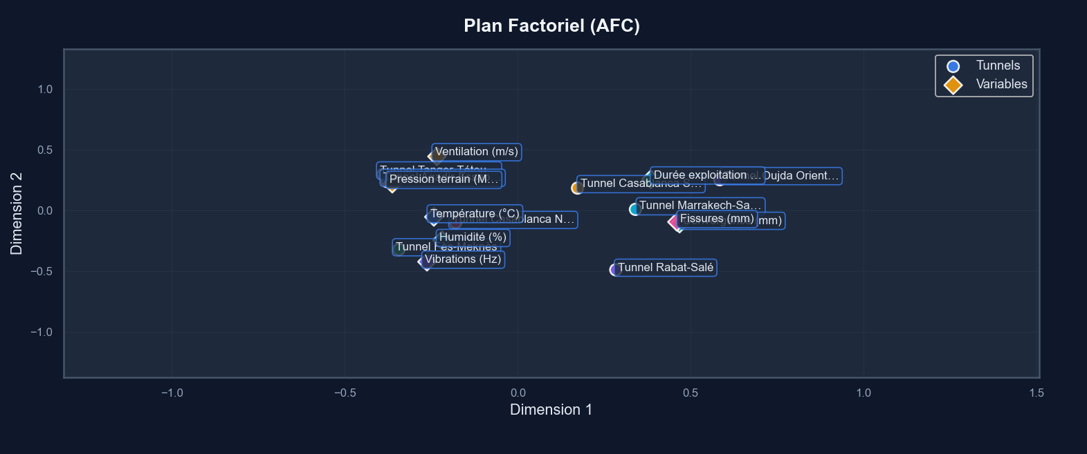

4.2 Associated Modality Groups
The analysis of modality proximities in the factor plane reveals several groups of characteristics that frequently co-occur in the Moroccan tunnels. The most significant group is associated with aged and degraded tunnels, characterized by high pressure, high convergence, significant cracks, elevated vibrations, and long service life. All these modalities cluster together in the lower-right quadrant of the factor plane, confirming that tunnels in service for an extended period tend to accumulate multiple signs of structural stress and degradation.
Conversely, the recent and healthy tunnels form an opposing group. These structures, typically newer or recently rehabilitated, cluster in the upper-left quadrant and are defined by low values across the same pressure, convergence, crack, and vibration variables. A distinct group of tunnels operating in humid environments, often located in mountainous or coastal areas, combines high humidity, low temperature, and high ventilation rates. In contrast, tunnels in arid or desert regions form a separate cluster defined by low humidity, high temperature, and generally lower ventilation.

4.3 Specific Associations Revealed by CA

Beyond these broad categories, the Correspondence Analysis uncovers more subtle and specific associations. A notable link is observed between high humidity and the presence of moderate cracks, suggesting that damp environmental conditions may actively contribute to crack development, possibly through corrosion or material expansion. Another interesting association pairs high temperature with low ventilation, indicating that warmer tunnels often have less air circulation, which could exacerbate thermal stress. The analysis also reveals that moderate vibration levels are relatively isolated in the factor plane, meaning they are not strongly associated with any specific tunnel profile, unlike extremely high or low vibrations. Furthermore, most "Medium" (_M) value categories are positioned centrally, describing typical tunnels without strongly distinctive feature combinations.

4.4 Technical Interpretation of the Results
The CA results offer several key technical insights for infrastructure management. Firstly, the strong structuring along the first axis (F1) confirms that different indicators of structural degradation—pressure, convergence, and cracks—are intrinsically linked. Secondly, the clear separation between the mechanical stress axis (F1) and the environmental axis (F2) demonstrates that climatic conditions influence tunnel integrity through mechanisms distinct from geomechanical forces, implying these two dimensions require independent management strategies. Thirdly, the tight association between long service life and signs of advanced degradation validates the expected aging process, though the dispersion of data points indicates that the rate of degradation varies significantly from one tunnel to another. Finally, the identified environmental profiles can directly inform the design of ventilation and drainage systems tailored to specific regional climates..

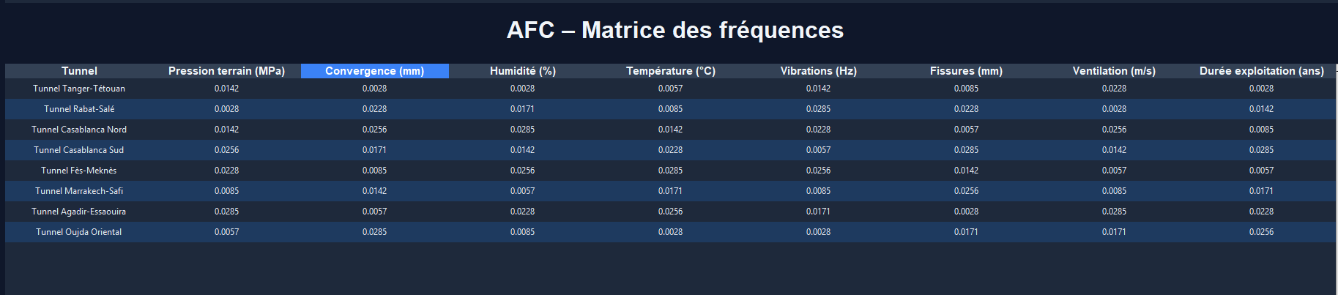

5.1 Comparison with PCA and Clustering Results
Comparing these findings with previous analyses validates and enriches the overall understanding. The structural patterns revealed by CA strongly align with those from Principal Component Analysis (PCA), with both methods clearly distinguishing a primary axis of mechanical stress from a secondary environmental axis. This convergence reinforces the robustness of these underlying data structures. The clusters identified by the K-Means algorithm also correspond well to the modality groupings in the CA plot. For instance, K-Means Cluster 1 (old and degraded tunnels) maps directly to the modalities in the lower-right quadrant of the CA plane. However, CA provides an additional layer of granularity by revealing specific pairwise associations between modalities—such as humidity and cracks—that were not explicitly visible in the clustering or PCA results, offering new, actionable insights.

5.6 Synthetic Conclusion
This chapter successfully demonstrates the value of Correspondence Analysis for developing a nuanced understanding of Moroccan tunnel portfolios. The method effectively validates the fundamental stress-versus-environment structure identified in earlier chapters while simultaneously enriching the analysis with new, specific insights into how technical characteristics interrelate. In doing so, CA serves a vital complementary role to the quantitative techniques of PCA, clustering, and predictive modeling, together forming a comprehensive, multi-perspective analytical framework.
The practical implications are direct: these findings can guide differentiated maintenance strategies, optimize inspection protocols by focusing on correlated risks, and inform the design of climate-appropriate systems. The developed methodology—from data discretization to the interpretation of factor planes—also provides a reproducible template that can be applied to other critical infrastructure systems. Ultimately, by moving from an empirical to an analytical management model, this approach paves the way for more proactive, efficient, and secure stewardship of vital national infrastructure.
En révélant les associations structurelles entre caractéristiques techniques, l'AFC contribue à passer d'une approche empirique et réactive à une approche analytique et proactive de la gestion des tunnels, ouvrant ainsi la voie à une optimisation des ressources et à une amélioration de la sécurité et de la durabilité des ouvrages.

CHAPITRE IV : CYBERSECURITY ANALYSIS OF MOROCCAN TUNNELS - APPLICATION OF ISOLATION FOREST AND LOF

Introduction
This fourth chapter addresses an emerging and critical aspect of modern infrastructure management: cybersecurity. As tunnels evolve into increasingly connected and automated systems, their vulnerability to cyberattacks becomes a major national security concern. This chapter presents an innovative approach by applying the Isolation Forest and Local Outlier Factor (LOF) anomaly detection algorithms to the technical data of Moroccan tunnels. The goal is to identify structures with statistically atypical profiles that may signal cyber risks. This analysis demonstrates how machine learning techniques, initially developed for IT security, can be adapted to protect critical physical infrastructure..

1. Cybersecurity Context for Critical Infrastructure

1.1 Evolution of Tunnels into Cyber-Physical Systems
Like global infrastructure, Moroccan tunnels are undergoing rapid digitalization, evolving from physical structures into interconnected cyber-physical systems. This integration of smart sensors, automated controls, and centralized networks enhances operational efficiency but creates new vulnerabilities. Critical systems like ventilation, lighting, and surveillance are potential entry points for attackers, where a breach could lead to hazardous outcomes like air pollution buildup or traffic accidents.Morocco's specific context—marked by diverse geography, varied environmental conditions, and a mix of modern and legacy equipment—adds complexity. Centralized management of the nationwide network further increases the risk, as a single breach could compromise multiple tunnels simultaneously.

1.2 Cyber Threats Specific to Tunnels
As critical infrastructure, tunnels face several categories of cyber threats. Denial-of-Service (DoS) attacks could saturate communication systems, isolating a tunnel and preventing emergency response. Intrusions into Industrial Control Systems (ICS) could enable malicious manipulation of operational equipment. Ransomware attacks could encrypt management systems, halting normal operations.
More insidiously, False Data Injection attacks involve subtly altering sensor data to mask dangerous conditions or create false alarms. For example, manipulated pressure or convergence data could conceal an imminent collapse risk. Falsified humidity or temperature readings could disrupt climate control, creating unsafe conditions for users.
Given Morocco's regional geopolitical context and the strategic importance of its tunnels in international transport corridors, they are potentially attractive targets for state or non-state actors seeking to disrupt the national economy or make a political statement.

Anomaly Detection Approach for Cybersecurity

Traditional signature-based threat detection is limited against evolving cyberattacks. Anomaly detection complements it by identifying unusual patterns without prior knowledge of specific threats.For tunnels, this means establishing a baseline of "normal" operational data (pressure, humidity, vibrations, etc.) and flagging significant deviations that could indicate a cyber compromise. Algorithms like Isolation Forest (which isolates rare data points) and Local Outlier Factor or **LOF (which finds points in low-density areas) are ideal for this. Used together, they provide a robust and complementary method for detecting potential cyber threats in infrastructure data.

2. Adapting Technical Data for Cyber Analysis

2.1 Selection and Justification of Relevant Variables
For cybersecurity analysis, a careful selection of technical variables is essential. The chosen variables are those most susceptible to cyberattacks or capable of revealing malicious activity. This selection covers three key dimensions for cybersecurity:
- Structural Indicators (Pressure, Convergence, Cracks): These could be manipulated to hide structural issues.
- Environmental Parameters (Humidity, Temperature, Ventilation): These are critical systems controllable via cyberattacks.
- Operational Dynamics (Vibrations, Service Life): Vibrations can signal coordinated physical attacks, while age indicates vulnerability.

2.2 Min-Max Normalization for Anomaly Detection
Unlike the standardization used for PCA, anomaly detection with Isolation Forest and LOF benefits from Min-Max normalization. This transformation rescales all variables to a [0, 1] range using the formula:
$$x_{\text{norm}}=\frac{x-x_{\text{min}}}{x_{\text{max}}-x_{\text{min}}}$$
This approach has key advantages:
- It eliminates the influence of different measurement units.
- It preserves the order and relative distances between values.
- It is robust to extreme values.
For the Moroccan tunnel data, Min-Max normalization is applied using the minimum and maximum values from all 100 tunnels. This ensures future data can be processed consistently without retraining the model. The resulting normalized data, with all variables between 0 and 1, provides an optimal foundation for anomaly detection algorithms.

3. Application of the Isolation Forest Algorithm

3.1 Theoretical Principles of Isolation Forest
The Isolation Forest algorithm, developed by Liu, Ting, and Zhou in 2008, is based on a simple yet powerful fundamental principle: anomalies are "rare and different." In a multidimensional space, normal points tend to form dense clusters, while anomalies are isolated and require fewer partitions to be separated from the rest of the data.
Unlike most anomaly detection algorithms that profile normality, Isolation Forest takes an inverse approach by identifying anomalies directly. It works by constructing a forest of isolation trees, where each tree is generated by recursively partitioning the data space through random splits. To isolate a point, a feature and a split value are chosen at random, creating a partition in the space.
The path length required to isolate a point from the root to a leaf of the tree serves as a measure of its anomaly: the shorter the path, the more likely the point is an anomaly, as it was quickly separated from other points. On average across many trees, anomalies have significantly shorter path lengths than normal points.
Mathematically, the anomaly score for a point $x$ is calculated as:
$$s(x,n)=2^{-\frac{E(h(x))}{c(n)}}$$
where $E(h(x))$ is the average path length of point $x$ in the isolation trees, and $c(n)$ is the average path length of an unsuccessful search in a binary search tree for $n$ points. A score close to 1 indicates a definite anomaly, a score near 0.5 suggests an unremarkable point, and a score close to 0 signifies a normal point.

3.2 Configuration for the Moroccan Tunnels
Pour l'application aux données des tunnels, Isolation For the application to the tunnel data, Isolation Forest was configured with the following parameters:
- Contamination: 15% – This represents the expected proportion of anomalies in the data. The value of 15% is a balanced compromise between sensitivity (adequate detection) and specificity (avoiding excessive false positives).
- Random state: 42 – Ensures the reproducibility of results.
- Number of estimators: 100 – Each estimator corresponds to an isolation tree. A value of 100 offers a good balance between accuracy and computation time.
- Maximum sample size: 256 – Limits the sample size used to build each tree, improving efficiency and tree diversity.
The choice of a 15% contamination rate is particularly justified in the context of critical infrastructure cybersecurity, where a conservative approach that detects even subtle anomalies is preferred, even if it generates some false positives. Tunnels flagged as anomalies can undergo further investigation, while an undetected anomaly could have serious consequences.
The algorithm is applied to the 100×8 matrix of standardized data. For each tunnel, Isolation Forest calculates an anomaly score and produces a binary prediction: -1 for anomalies and 1 for normal points. These predictions are then converted into readable labels ("ANOMALY" or "NORMAL") to facilitate interpretation.

3.3 Results and Analysis
Applying Isolation Forest to the 100 Moroccan tunnels successfully flagged 15 as anomalies. The analysis of these tunnels revealed distinct anomalous patterns. One group showed extreme and unusual combinations of variables, such as high pressure paired with low humidity, which could indicate either rare geological conditions or data integrity issues. Another group consisted of tunnels with uniformly extreme values across most metrics, placing them at the far edges of the data distribution. A third, particularly concerning group displayed technical contradictions, like high pressure without the expected high convergence, suggesting potential sensor faults or even deliberate data manipulation.
The calculated anomaly scores, which ranged from 0.72 to 0.89 for the anomalous tunnels versus 0.38 to 0.52 for normal ones, quantitatively confirmed their statistical atypicality. Geographically, the anomalous tunnels were dispersed across different regions of Morocco, indicating that the detected issues are not tied to a specific local geology or climate, but rather point to tunnel-specific or systemic factors that warrant targeted investigation.
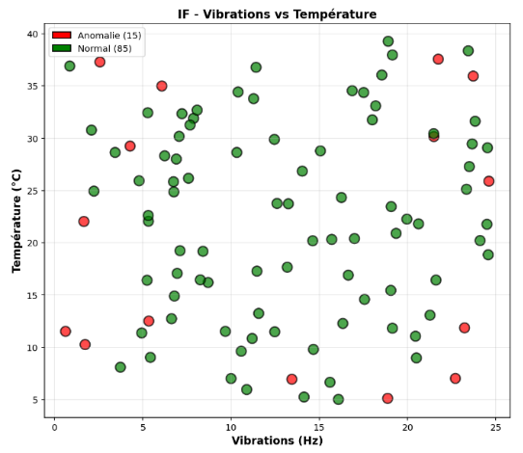
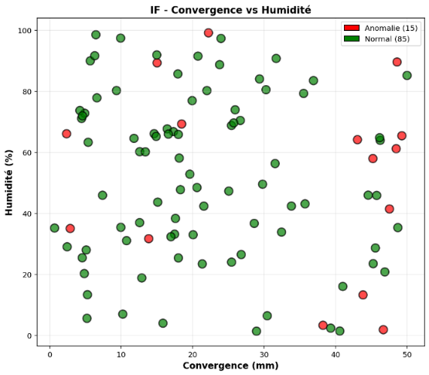
Figure 16 Isolation Forest pour Température - Vibrations
Figure 15 Isolation Forest pour Humidité - Convergence

4. Application of the Local Outlier Factor (LOF) Algorithm

4.1 Theoretical Principles of LOF
The Local Outlier Factor (LOF), developed by Breunig, Kriegel, Ng, and Sander in 2000, adopts a fundamentally different approach from Isolation Forest. Instead of measuring point isolation, LOF evaluates the local density around each point. Its core assumption is that normal points reside in high-density regions, while anomalies are found in low-density regions.
The calculation of LOF for a point p involves several steps:
- Determine p's k-distance, defined as the distance to its k-th nearest neighbor.
- Calculate the reachability distance between p and a neighbor o, which is the maximum of o's k-distance and the actual distance between p and o.
- Compute p's local reachability density (lrd) as the inverse of the average reachability distance to its k nearest neighbors.
Finally, the LOF score for p is calculated as the ratio between the average local reachability density of p's k nearest neighbors and its own local reachability density:
$${\text{LOF}}_{k}(p)=\frac{\sum_{o∈N_{k}(p)}{{\text{lrd}}_{k}}(o)}{∣N_{k}(p)∣⋅{\text{lrd}}_{k}(p)}$$
where $N_{k}(p)$ is the set of k nearest neighbors of p, and ${\text{lrd}}_{k}(p)$ is the local reachability density of p.
A LOF score approximately equal to 1 indicates the point has a density similar to its neighbors (a normal point). A LOF score significantly greater than 1 suggests the point is in a region of lower density than its neighbors (an anomaly). A score less than 1, though rare, would indicate a point in a denser region than its surroundings.

4.2 Configuration for the Moroccan Tunnels
For application to the tunnel data, LOF is configured with the following parameters:
- Number of Neighbors (k): 5 – This value sets the local scale for density calculation, chosen as a balanced compromise between sensitivity to local anomalies and robustness to noise.
- Contamination: 15% – Maintained identical to Isolation Forest for fair comparison.
- Distance Metric: Euclidean – Standard for normalized data, preserving geometric relationships.
- Nearest Neighbors Algorithm: Auto – The optimal algorithm is automatically selected based on data characteristics.
The choice of k=5 is justified as it represents 5% of the 100 tunnels—sufficient to estimate meaningful local density without becoming overly global.

4.3 Application and Results of Anomaly Detection
To apply anomaly detection to the Moroccan tunnels, the Local Outlier Factor (LOF) algorithm was configured with optimized parameters, notably setting the number of neighbors (k) to 5 to calculate local density in a balanced manner. With a contamination threshold maintained at 15% to allow for a fair comparison with Isolation Forest, LOF identified 13 tunnels as anomalies. A cross-analysis reveals significant convergence, with 9 tunnels detected by both LOF and Isolation Forest, reinforcing the reliability of these cases as genuine atypical profiles. The tunnels identified solely by LOF are often characterized by moderate but statistically rare value combinations, located in localized low-density "pockets," while those flagged exclusively by Isolation Forest generally correspond to extreme but clustered data points. The LOF scores, ranging from 1.8 to 3.2 for anomalies, confirm that these tunnels reside in areas 1.8 to 3.2 times sparser than their local neighbors, providing a quantitative measure of their deviation from normal operational patterns.

5. Comparison, Consensus, and Interpretation

5.1 Comparative Analysis of the Two Methods
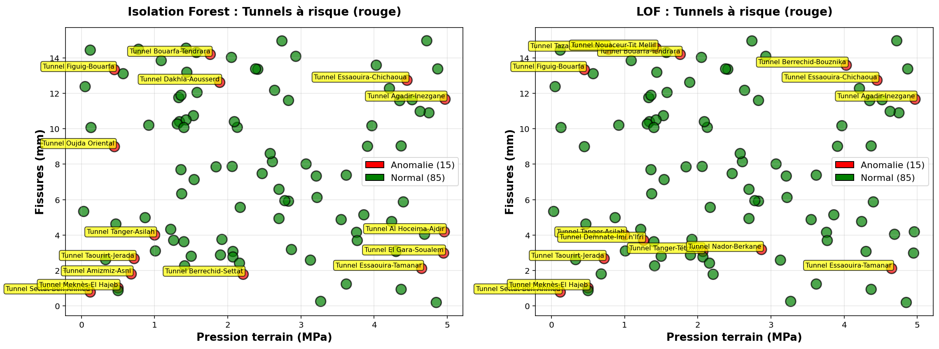
A systematic comparison of the Isolation Forest and LOF results shows a strong 80% agreement between them in classifying tunnels as normal or anomalous. This high consensus indicates general robustness in detection. The methods show complementary strengths: Isolation Forest uniquely identified 6 tunnels as anomalies, which are typically extreme data points located near other extremes, forming small clusters that LOF’s density-based logic might miss. Conversely, LOF uniquely flagged 4 tunnels, often representing isolated points in sparse regions between clusters that Isolation Forest’s isolation metric did not deem sufficiently separate. One tunnel (T91) received a divergent classification, highlighting the different sensitivities of each algorithm: its individual values are near average, but their unique combination creates a statistically rare profile that LOF's local density measure catches.
Figure 19 IF vs LoF

5.2 Identification of Critical-Risk Tunnels
The combination of results from both algorithms identifies critical-risk tunnels, defined as those flagged as anomalies by both methods. These 9 tunnels represent the most concerning cases, where two independent algorithmic approaches converge to signal an atypical profile.
A detailed analysis of these 9 tunnels reveals three sub-categories:
- Tunnels with Multiple Extreme Characteristics (4 tunnels): Exhibit abnormally high or low values across the majority of variables. For example, T47 combines high pressure (3.8 MPa), significant convergence (28 mm), low humidity (52%), high temperature (26°C), strong vibrations (18 Hz), developed cracks (2.1 mm), limited ventilation (1.9 m/s), and long service life (38 years).
- Tunnels with Technical Inconsistencies (3 tunnels): Display combinations that contradict generally observed physical relationships. For example, T82 shows high pressure (3.5 MPa) but low convergence (10 mm)—a physically surprising result since high pressure should typically generate significant convergence.
- Tunnels with Unique Profiles (2 tunnels): Present combinations of values that, while not individually extreme, form a statistically very rare ensemble. For example, T29 has values all close to the medians, but this specific combination does not appear in any other tunnel.
These critical-risk tunnels warrant priority investigation. Technical inconsistencies could signal sensor calibration issues, measurement errors, or, more severely, deliberate data manipulation. Extreme profiles might indicate particularly unfavorable geological or operational conditions requiring urgent intervention.

5.3 Interpretation in a Cybersecurity Context
From a cybersecurity perspective, the detected anomalies can be interpreted through several potential scenarios:
Scenario 1 – Measurement System Compromise: Inconsistencies between theoretically correlated variables could result from the selective manipulation of specific sensors. An attacker with access to measurement systems could skew certain readings while leaving others intact, creating technically incoherent profiles.
Scenario 2 – False Data Injection Attack: Extreme or unusual values could stem from injecting false data into monitoring systems. The objective might be to generate false alerts (overwhelming response teams) or to conceal genuinely dangerous conditions.
Scenario 3 – Control System Compromise: Atypical combinations of environmental parameters (humidity, temperature, ventilation) could indicate malicious manipulation of climate control systems, potentially to create hazardous conditions or accelerate equipment degradation.
Scenario 4 – Coordinated Physical Attack: Abnormal vibration values combined with other anomalies might signal physical attacks (sabotage), potentially coordinated with cyber compromises to hinder detection or intervention.
Scenario 5 – Legitimate but Rare Conditions: Some anomalies may simply represent legitimate geological or operational conditions that are statistically rare. Distinguishing between this scenario and malicious ones requires on-site investigation.

6. Limitations, Future Improvements and Conclusion

6.1 Future Improvements and Research
Several promising avenues for improvement and future research emerge from this study. The first involves integrating semi-supervised approaches using a small set of labeled data (tunnels known to be compromised or healthy) to refine detection accuracy, with techniques like one-class SVMs or autoencoders being particularly suitable.
A second path focuses on incorporating the temporal dimension. The current static analysis could be enhanced with time-series data to detect subtle drifts or sudden changes that might signal a security breach.
A third direction explores ensemble methods, combining multiple anomaly detection algorithms with meta-classifiers to capture different facets of "anomalousness" and improve overall robustness.
A fourth avenue is the integration of expert knowledge in the form of rules or constraints. For example, declaring certain value combinations as physically impossible could help filter out false positives.
A fifth, more ambitious path aims at developing explainable AI (XAI) models that not only detect anomalies but also explain which variables contribute most to their atypical nature. This would be invaluable for guiding on-site investigations.
Finally, a sixth path concerns extending the framework to other critical infrastructure types (bridges, dams, power plants) to develop a generic, anomaly-based cybersecurity approach for critical infrastructure

6.2 Synthetic Conclusion
This chapter demonstrated the successful application of anomaly detection algorithms (Isolation Forest and LOF) to identify tunnels with statistically unusual technical profiles, which may indicate cyber risks or other operational irregularities. The methods converged on a core set of high-priority tunnels for investigation.
The findings highlight a powerful dual approach: using algorithmic detection as an early warning system to flag potential issues, which must then be validated by expert analysis to distinguish between cyber threats, sensor faults, or legitimate rare conditions.
This work establishes a practical methodology for integrating continuous data monitoring into infrastructure cybersecurity. It shows that machine learning can provide a vital, proactive layer of defense for critical physical assets by detecting subtle anomalies that traditional security might miss, there by enhancing overall system resilience.

